1. Install create-react-app globally if it is not installed, If you install NodeJS it will be there automatically
   1. 
2. Create demo app with below command
   1. 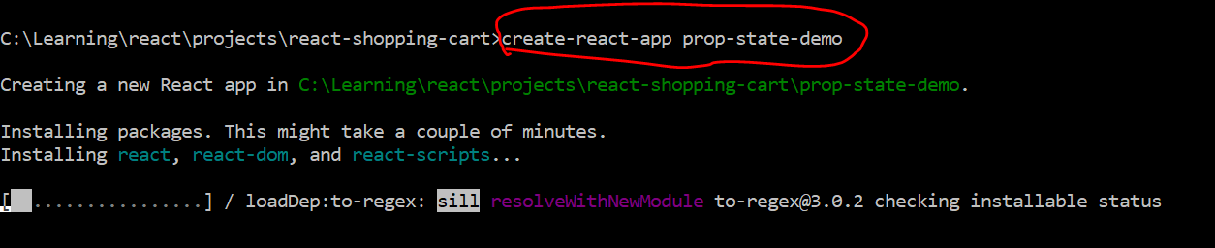
3. Go thru Project structure if required and default page
4. Create Counter component
   1. 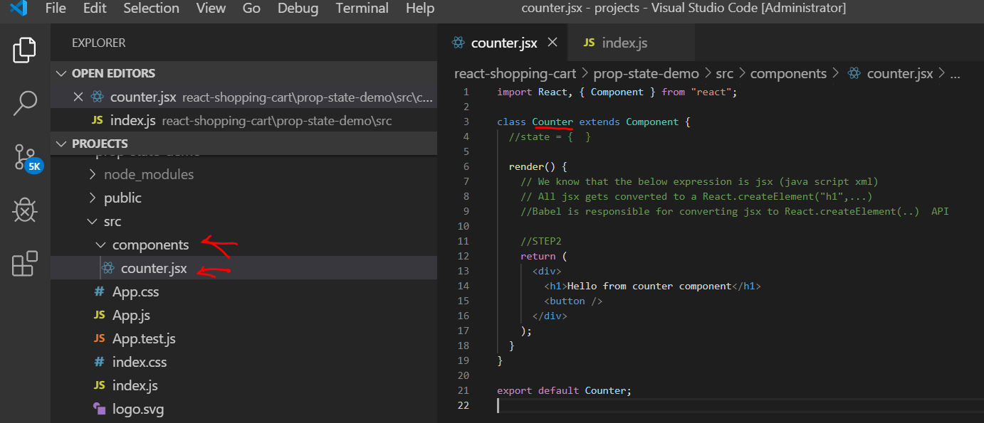
   2. Code

import React, { Component } from "react";

class Counter extends Component {

//state = { }

render() {

// We know that the below expression is jsx (java script xml)

// All jsx gets converted to a React.createElement("h1",...)

//Babel is responsible for converting jsx to React.createElement(..) API

//STEP2

return (

<div>

<h1>Hello from counter component</h1>

<button />

</div>

);

}

}

export default Counter;

1. Make below changes in index.js
   1. 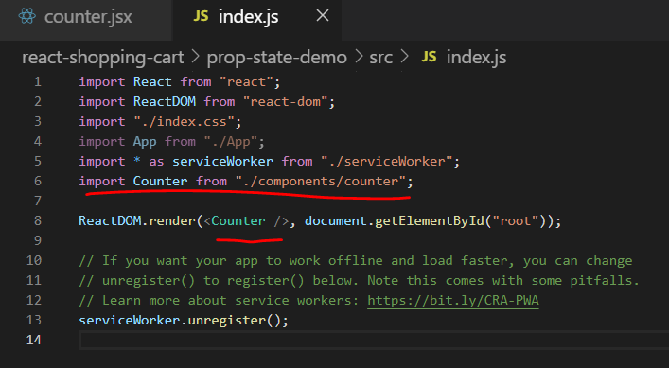
   2. 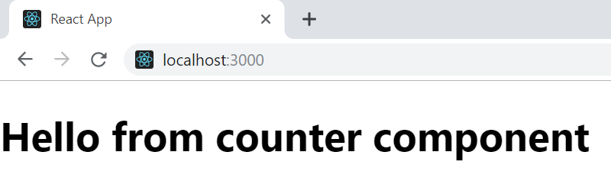
2. Add Bootstrap  
   1. 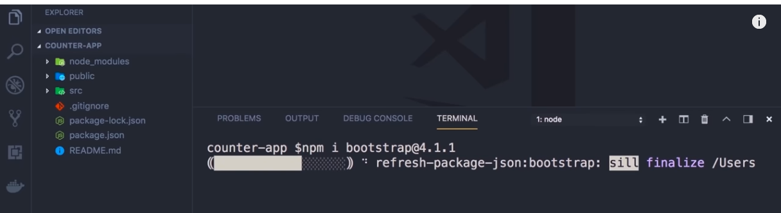

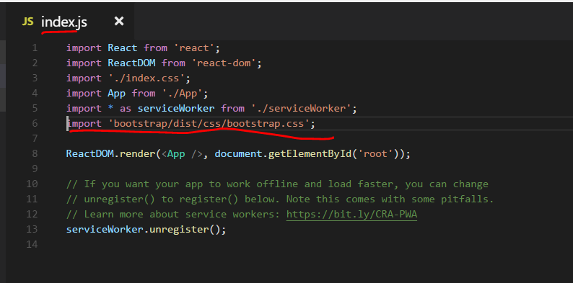

Imrc and cc

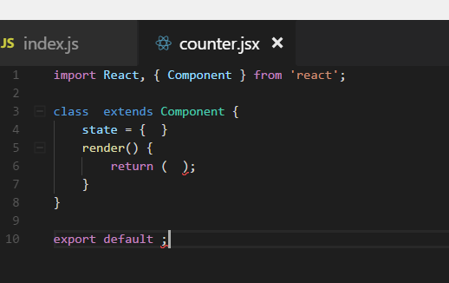

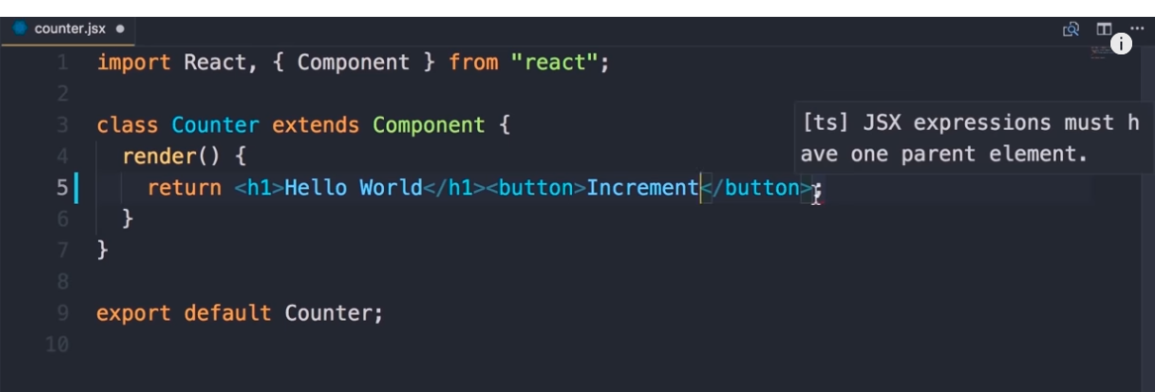

// We know that the below expression is jsx (java script xml)

// All jsx gets converted to a React.createElement("h1",...)

//React.createElement()

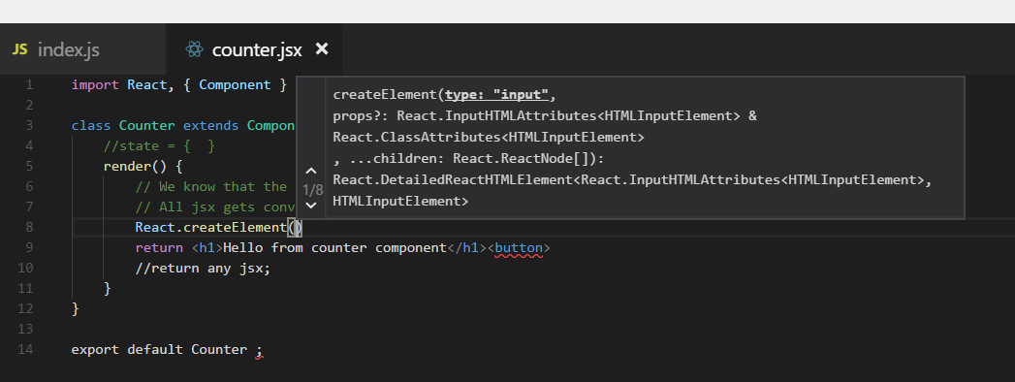

Jsx expressions are just like any other javascript objects and can be returned from a function or passed to a function

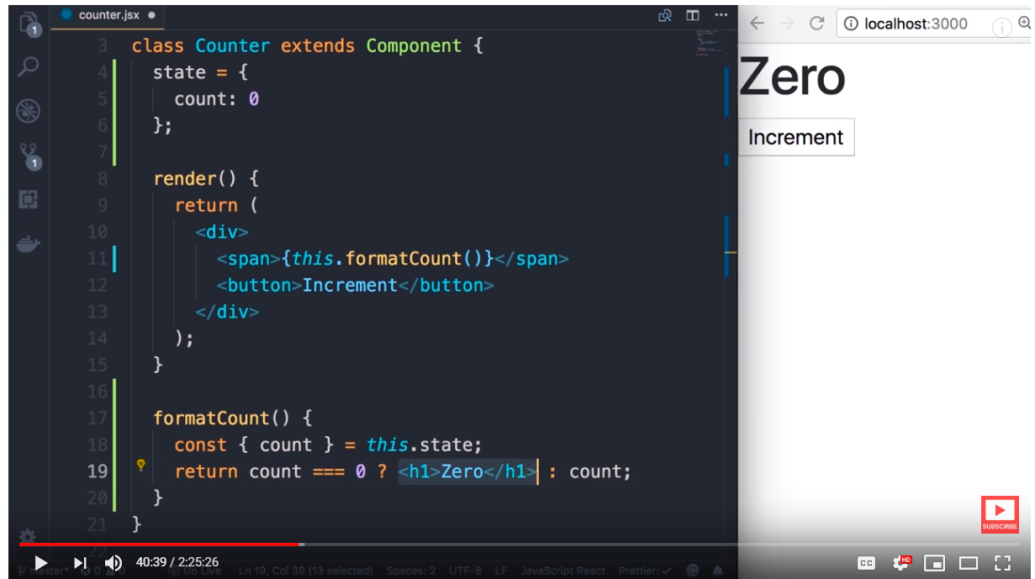

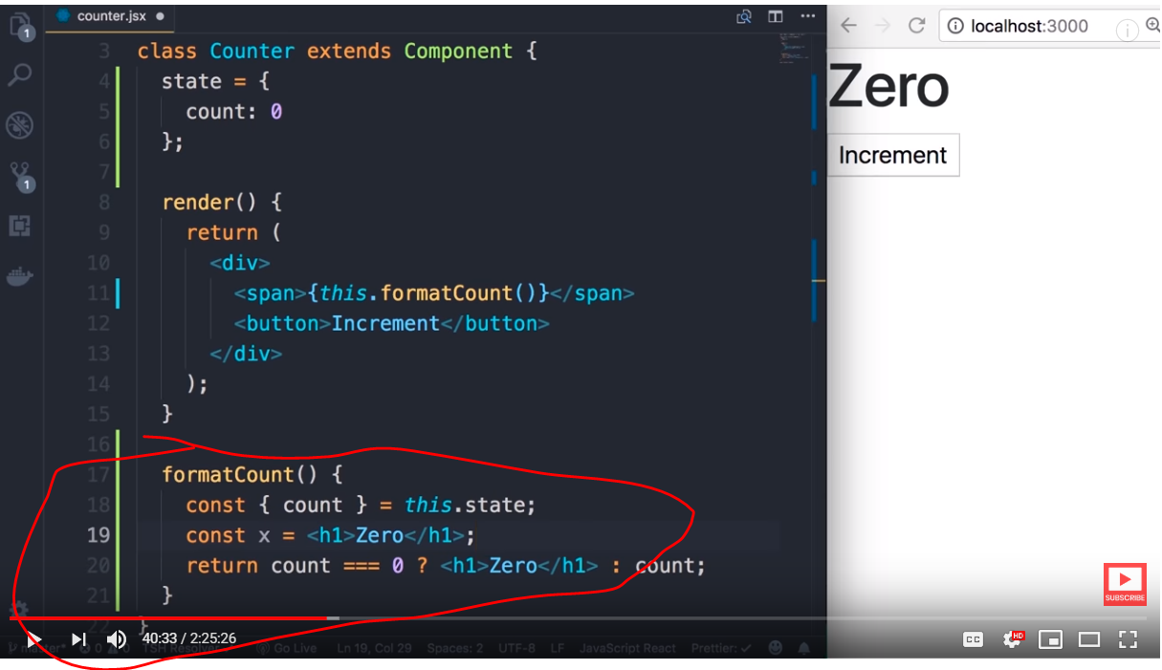



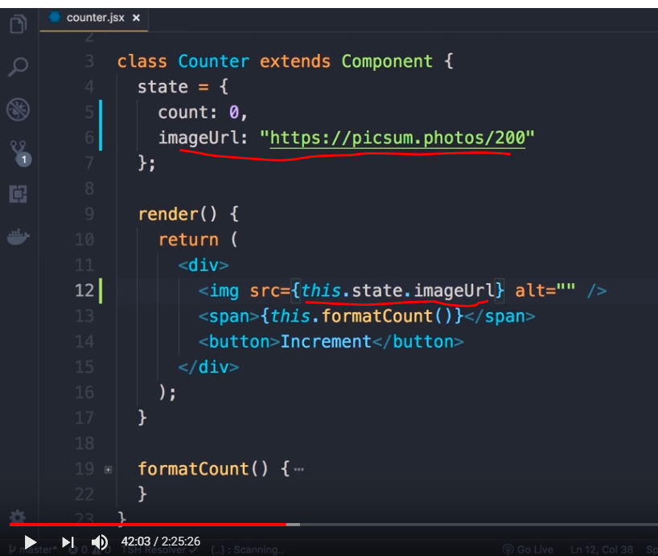

We can not use class attribute in jsx as it is a reserved keyword in javascript

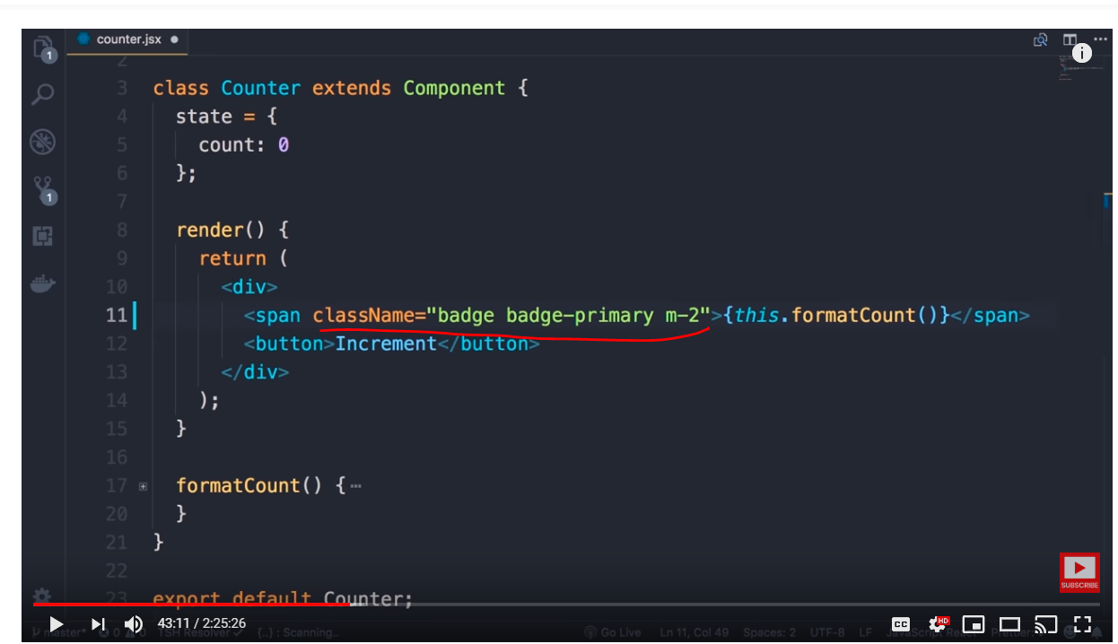

Style object usage

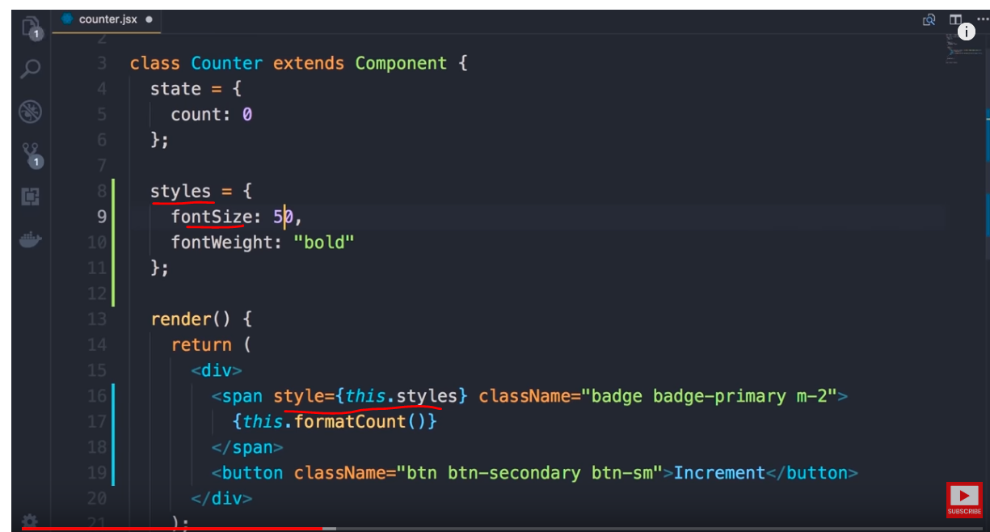

Inline style object

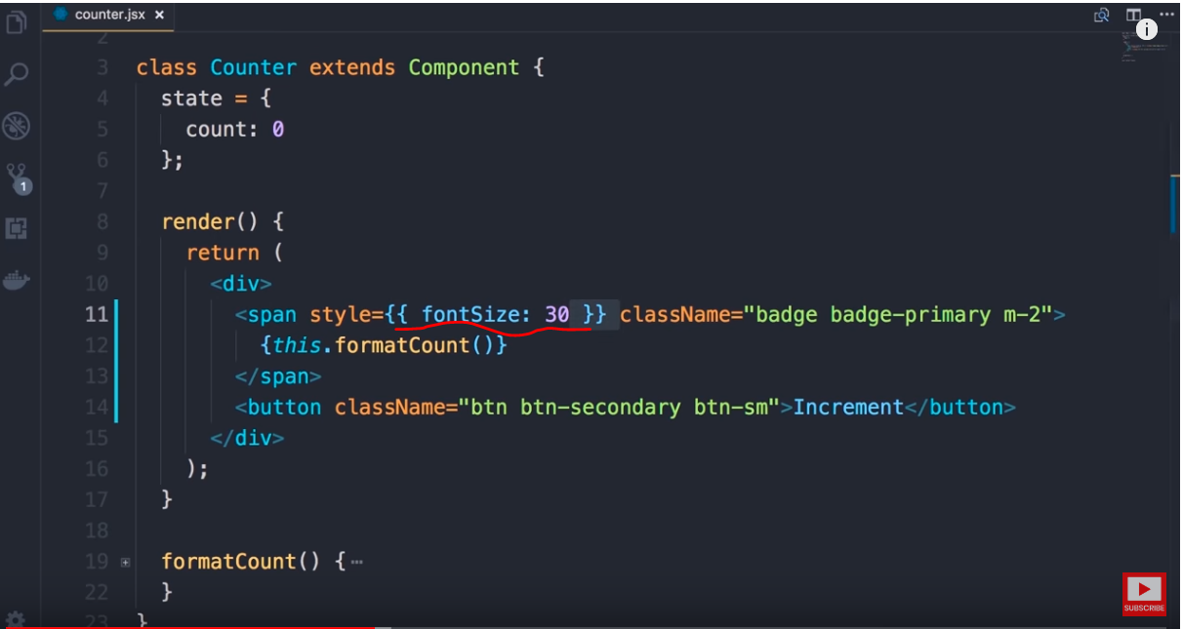

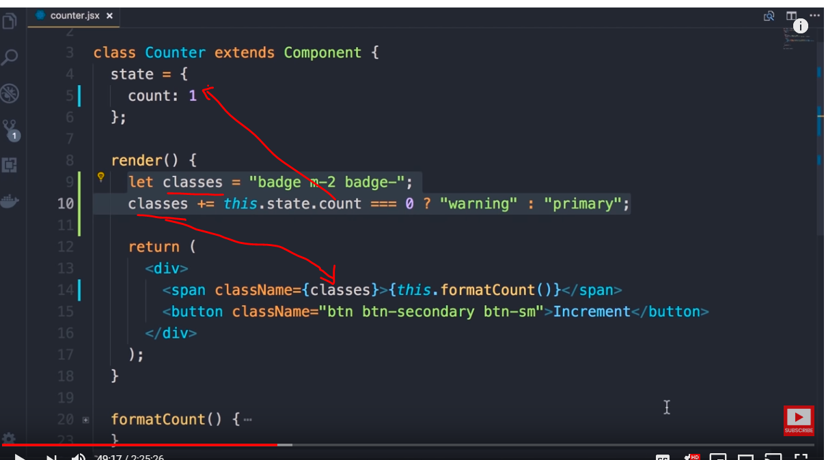

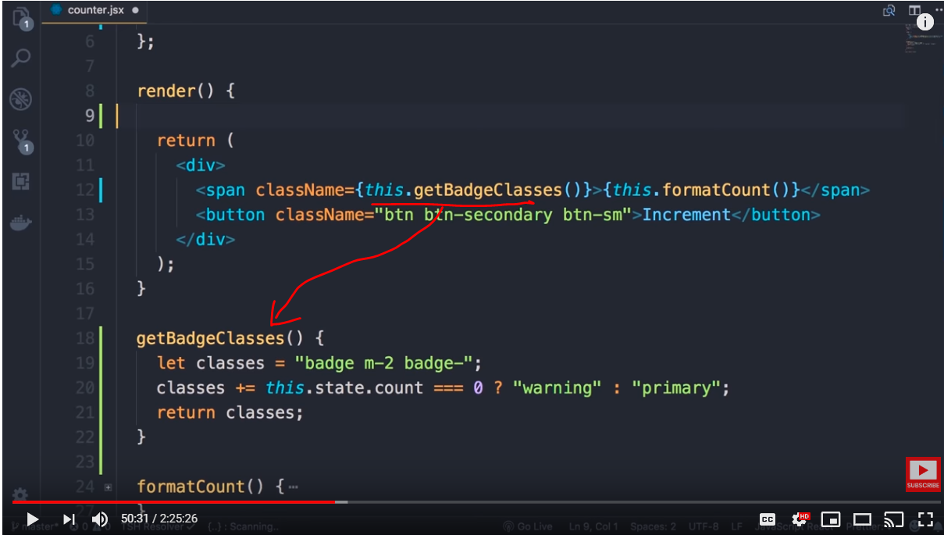

Next if you try to access count from the function you will get error as state is not accessible

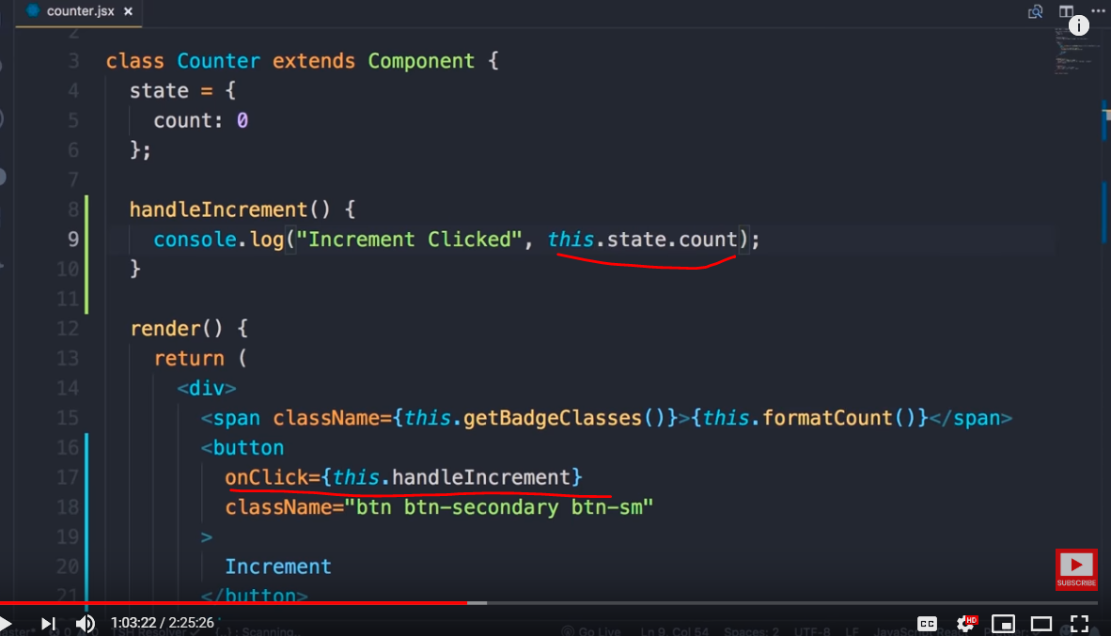

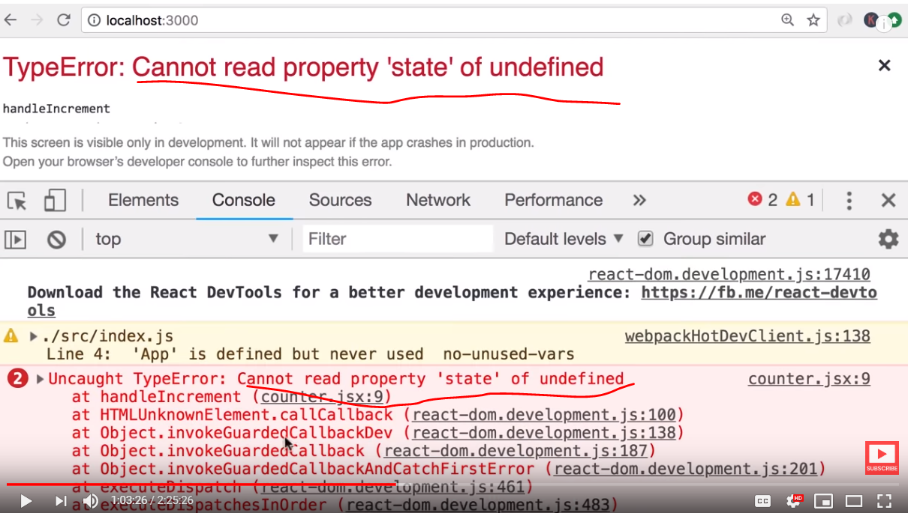

This issue is resolved in next topic

we can use arrow function which does inherit the this current object by default and no need to explicitly bind . This avoids rebinding every event manually

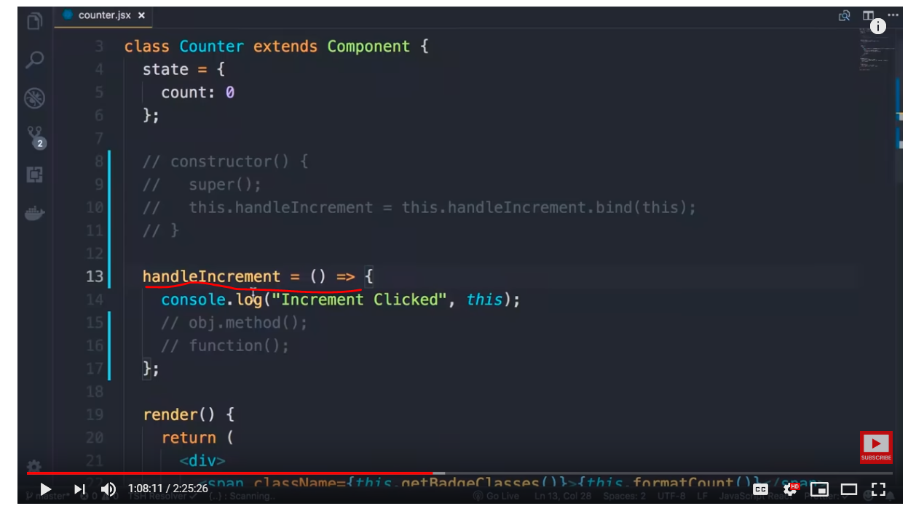

Now we have access to the state and we can increment the counter which is not going to work. This is because technically the counter is increasing but the react is not aware of it. We have explicitly tell react that the state has changed (we basically tell virtual DOM). After that the react will update the DOM(not virtual). In angular the change detection is automatic because they are monkey patched.

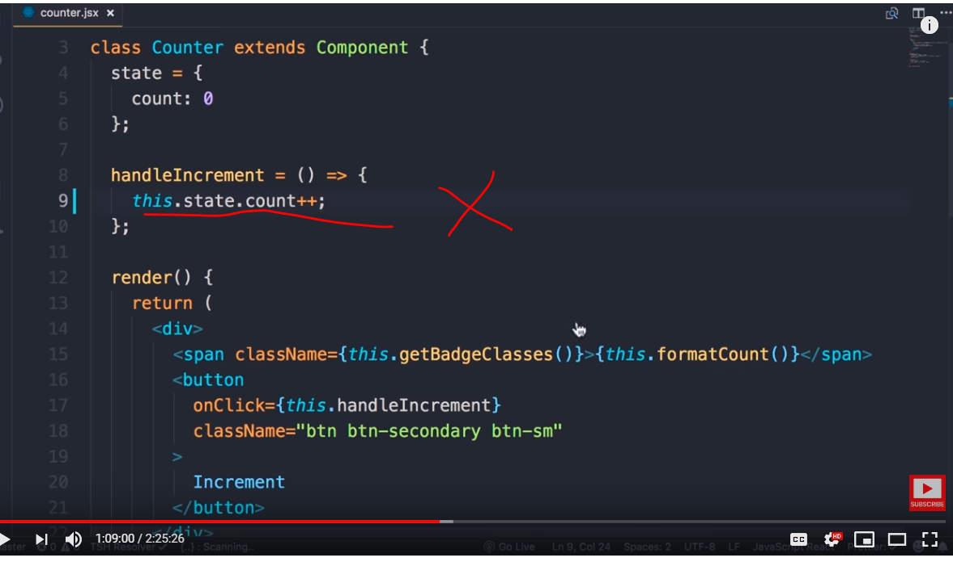

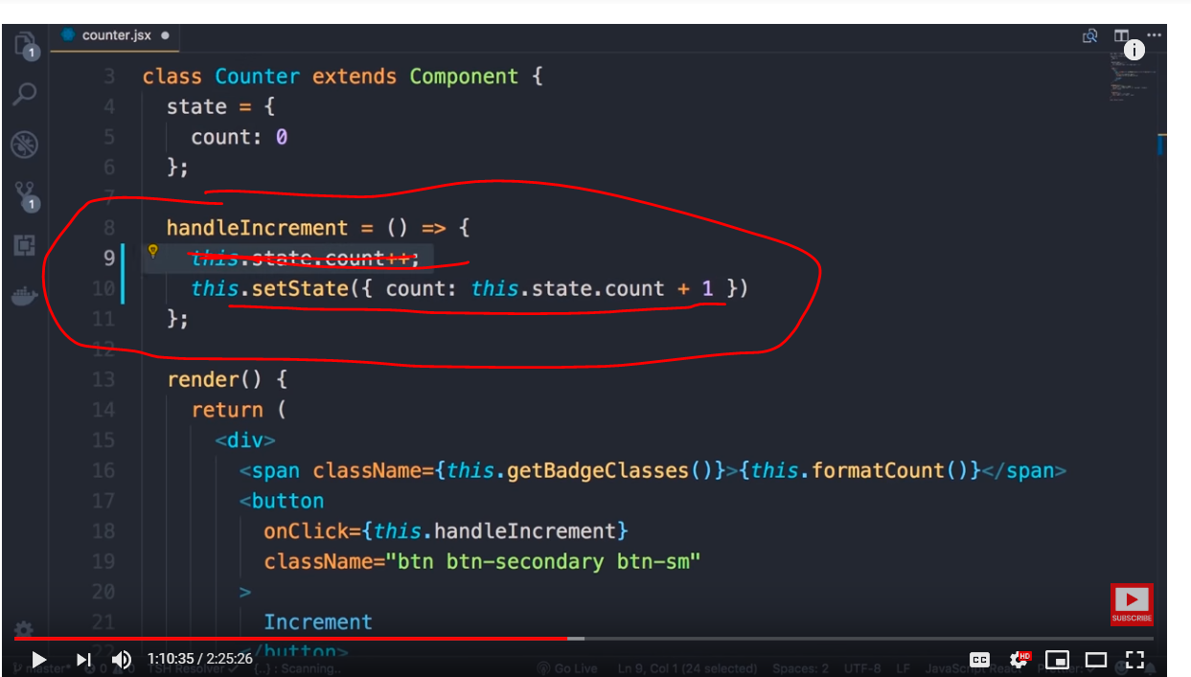



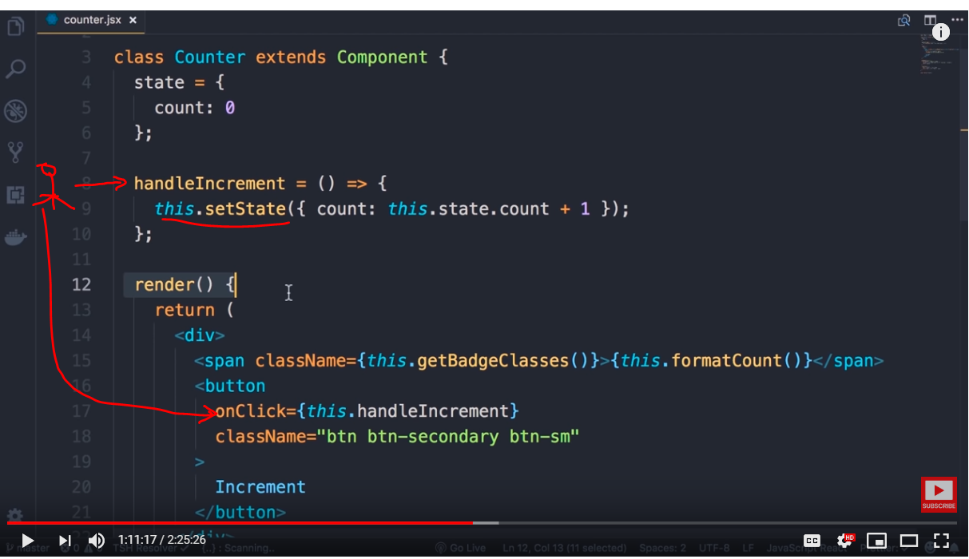

1. User clicks on the increment button
2. Handler tells react that the state of the component is going to change
   1. The click handler changes the state and informs react about change in state
3. React to is going to schedule a call to render() method and we do not know when , it could be 5 ms later or 10ms later
4. 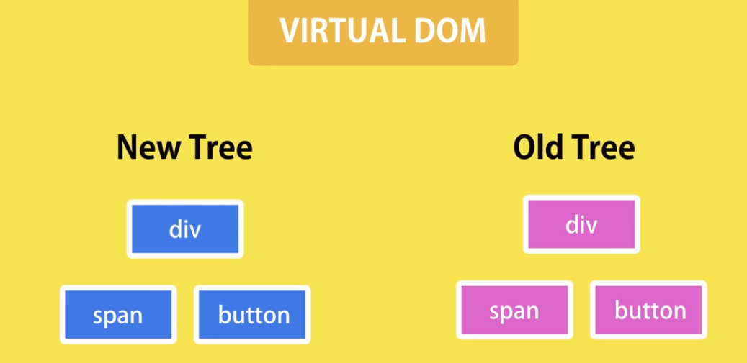
5. React will compare old virtual DOM with new virtual DOM and check what part of the DOM has changed
6. In our case it realizes that only span value has changed
   1. 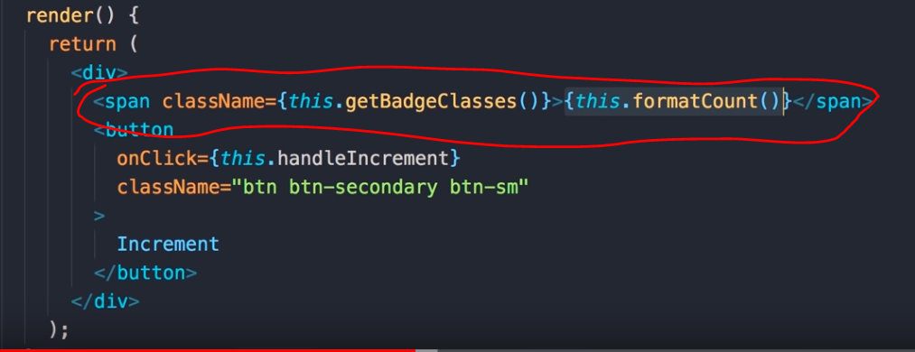
7. React reaches the actual DOM and modifies only span value and nothing else in DOM is affected
   1. 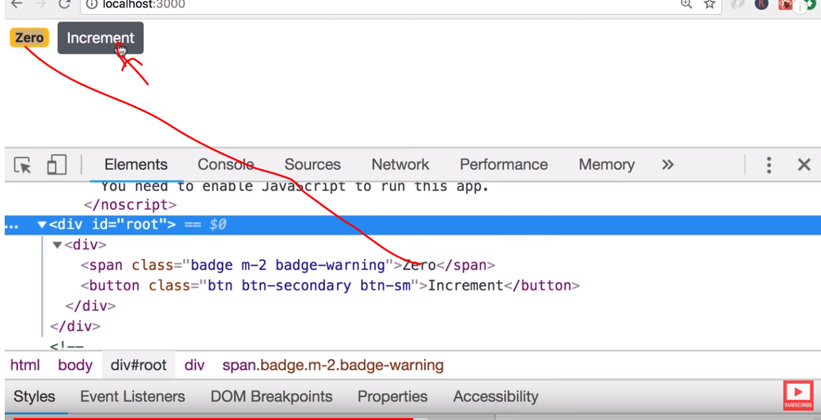
   2. 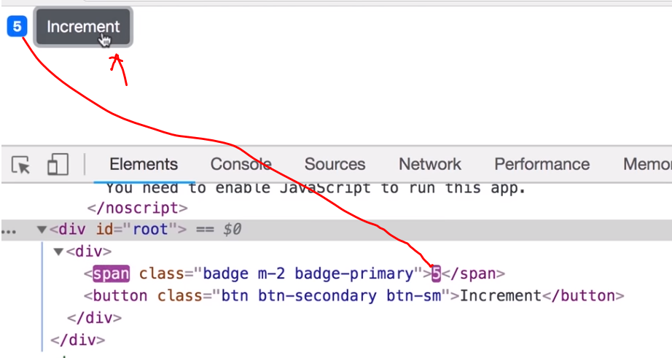



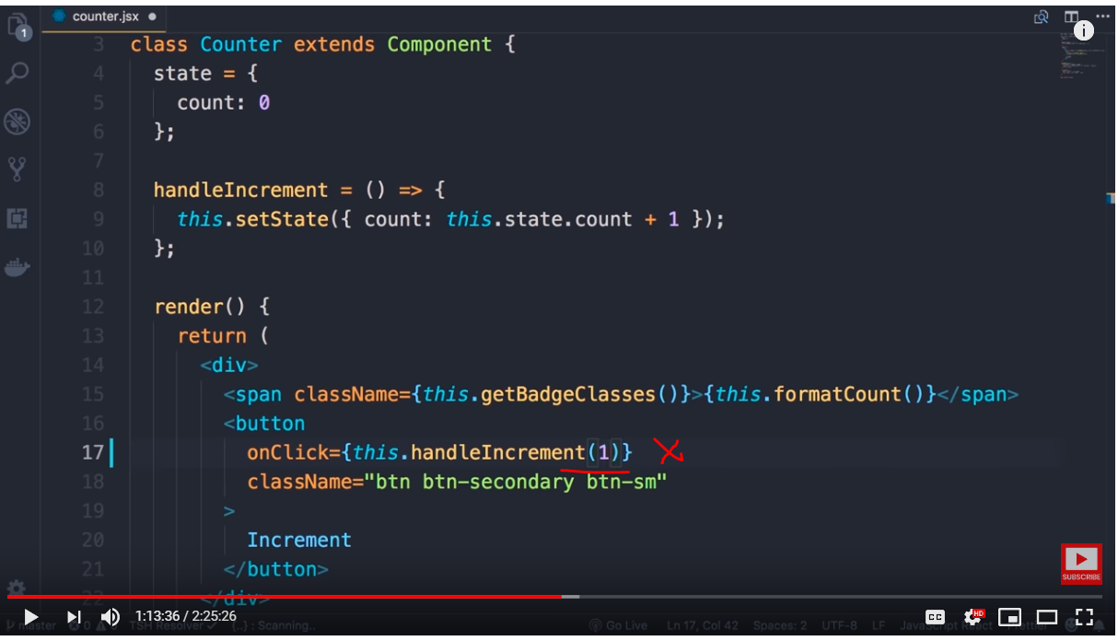

We can pass event arguments using below pattern

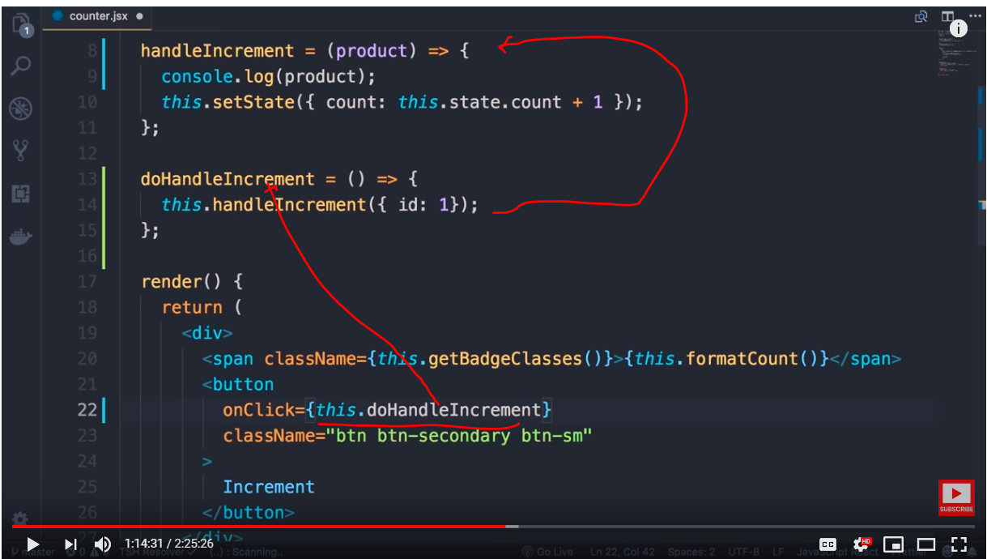

Note : the event onClick is taking only function reference

Another simplified pattern is using arrow functions

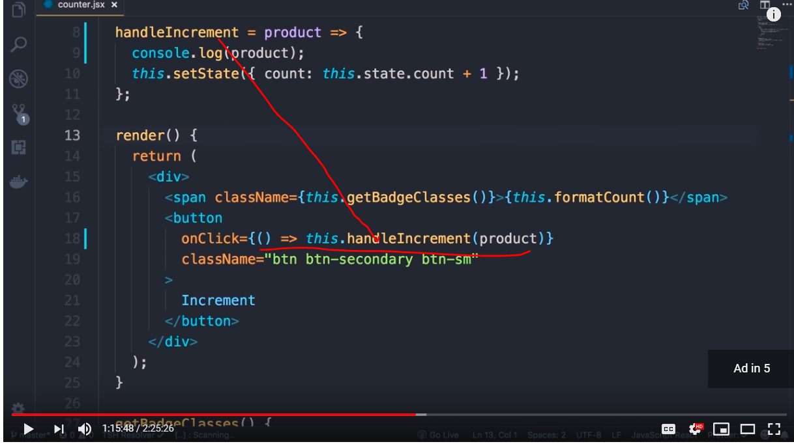

Summary

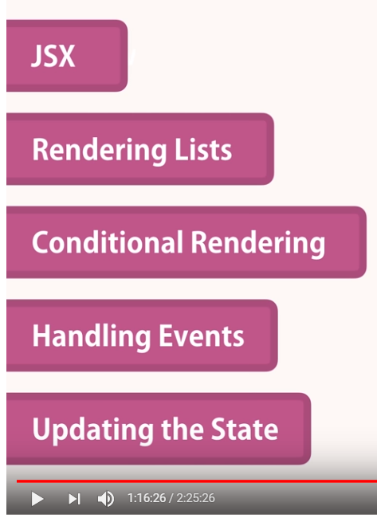

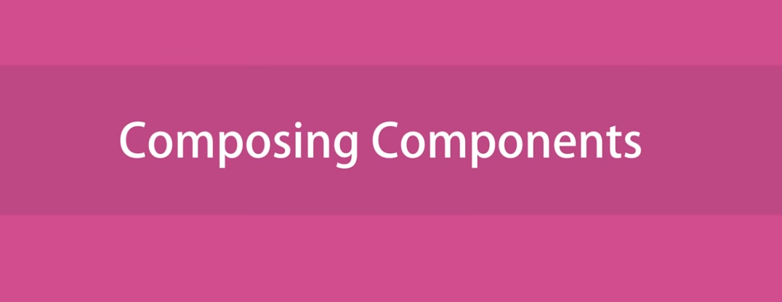

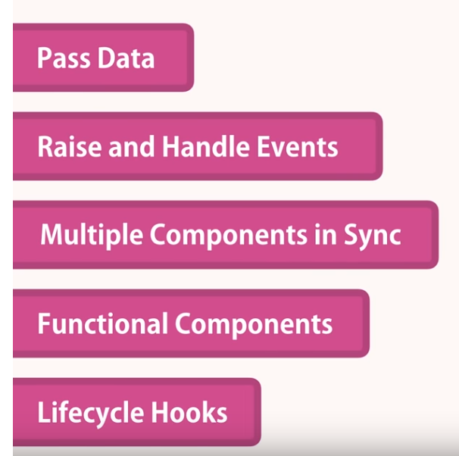



Now lets implement

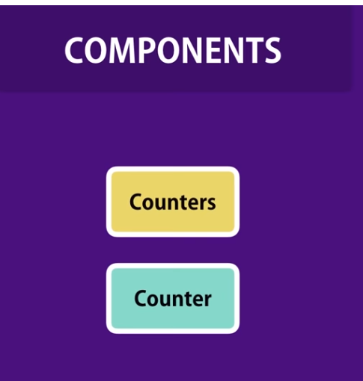

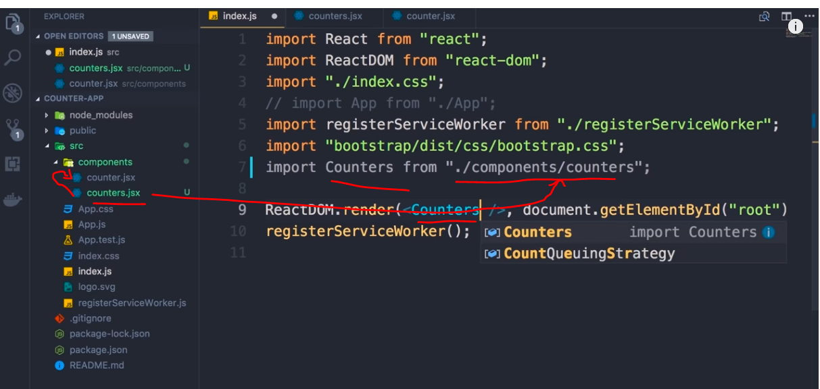

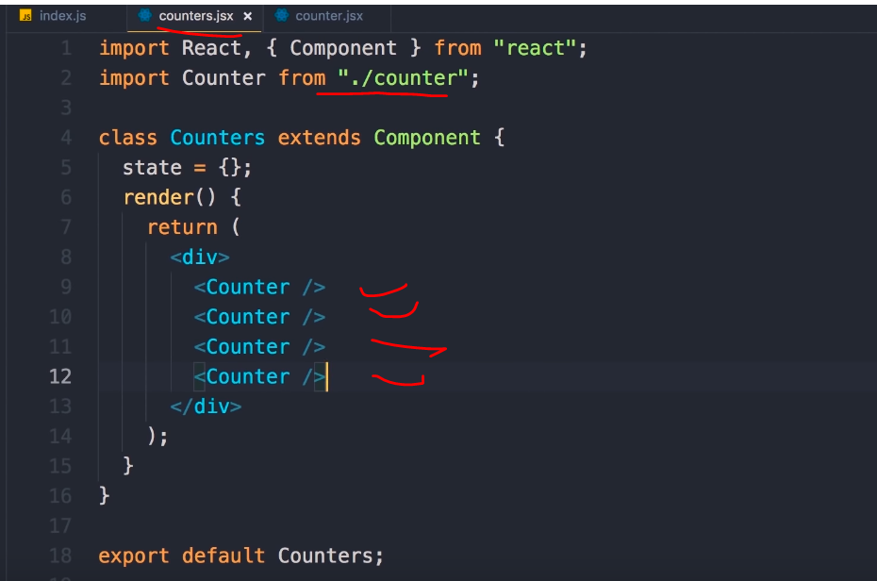 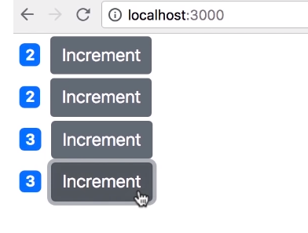

Repeate the component and each component has its own state that is completely isolated from each other

Improvise the code to below and still get the same output

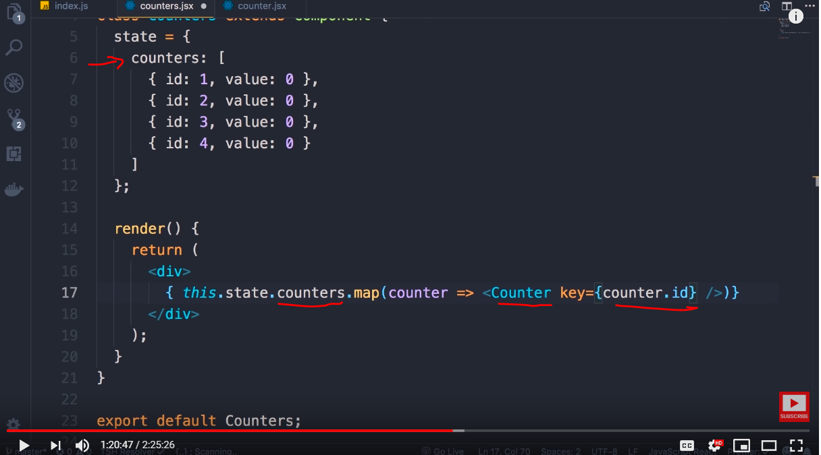 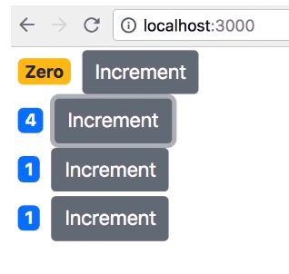

However we still not passing value to counter component



This is how we set the value

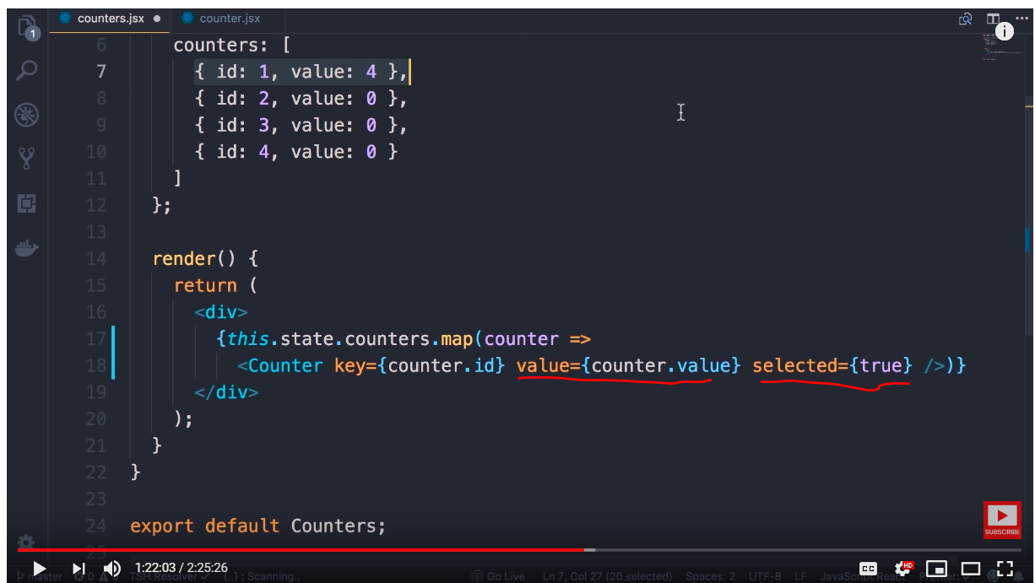

In the above example we are setting attributes and values to the counter component

Lets add console log inside the child component to print the attribute values passed by parent component

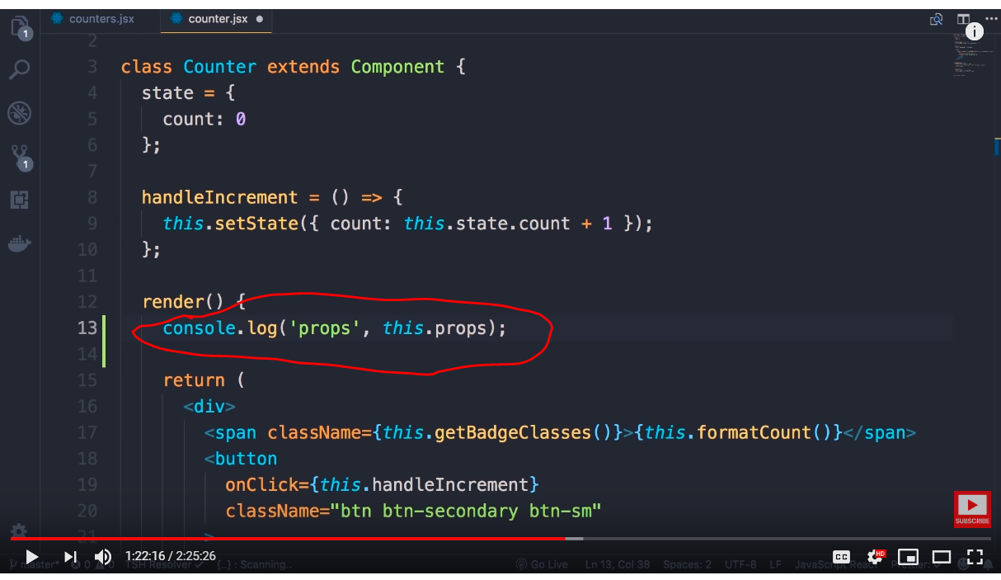

Props is a default property of every react component which holds all attributes and its values for the component

Note : Key attribute will not be part of it as it is a special attribute for uniqueness

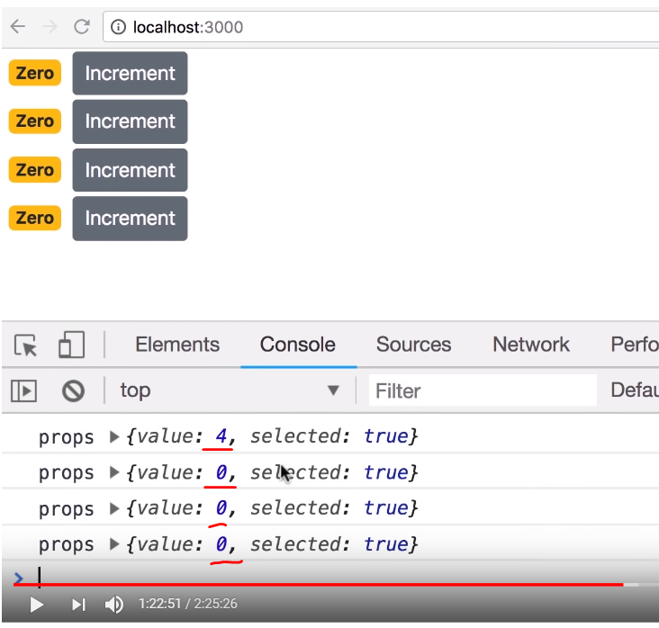

Porps is a plain java script object

Note : we are able to print the attribute values passed by parent , it is still not assigned to the child component state , we do that using below syntax

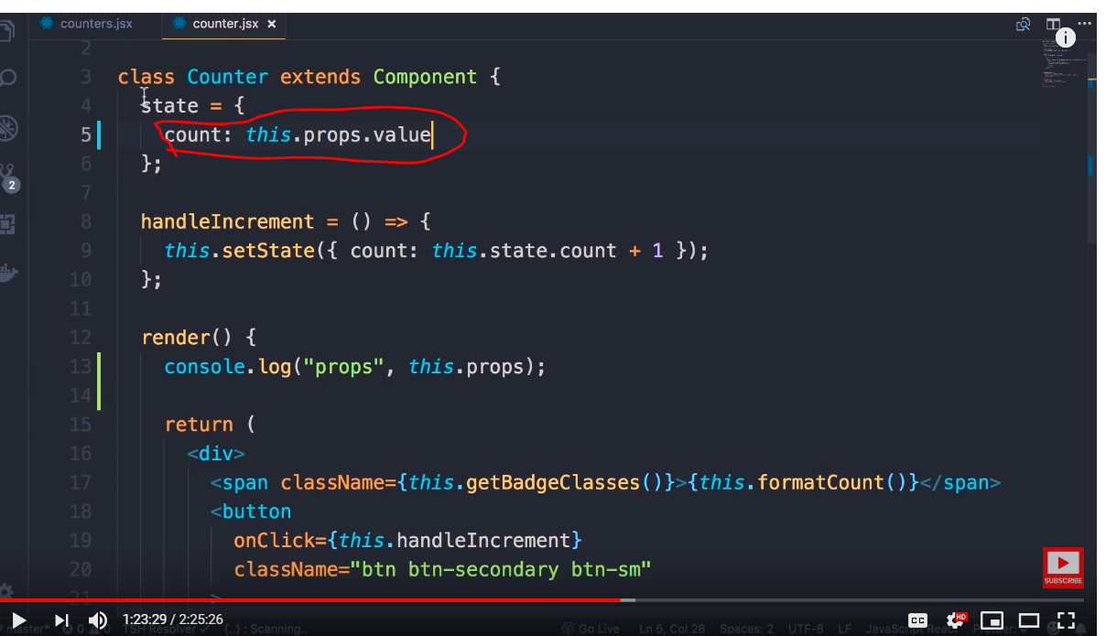



Lets say you want to pass some content to child component , for example lets say you have a message alert component and you want to pass title from parent like below

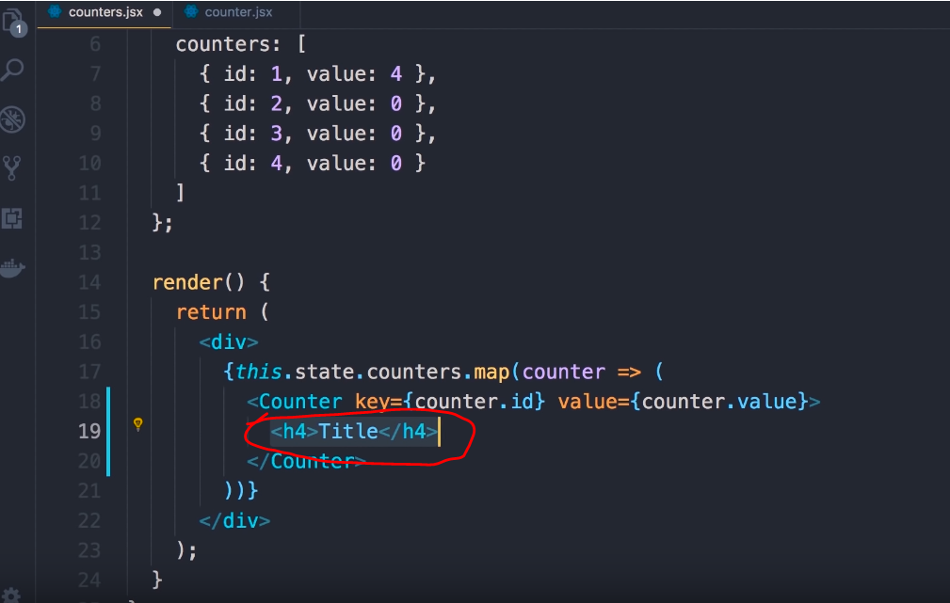 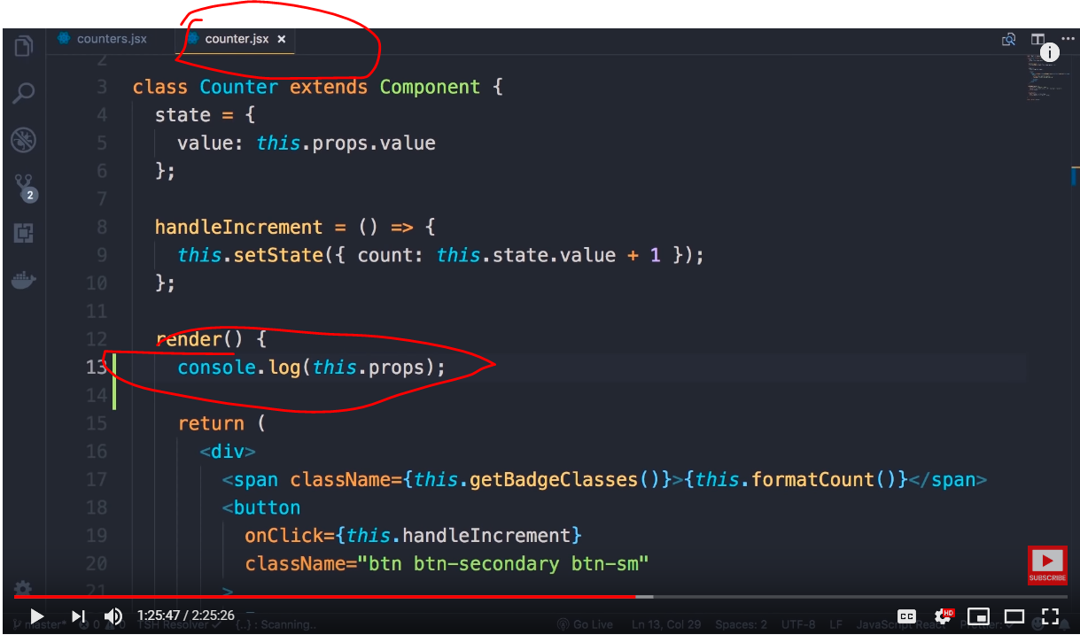

Now you have a new component called children

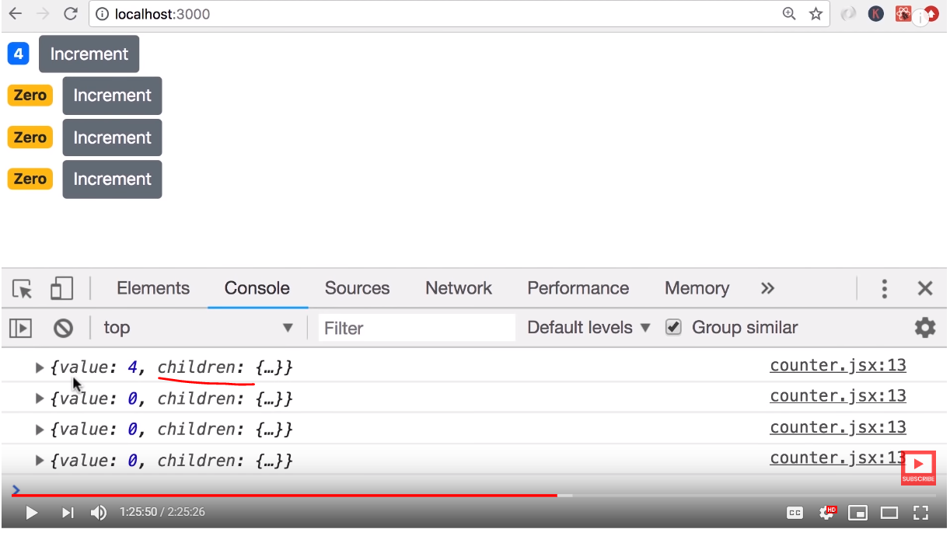 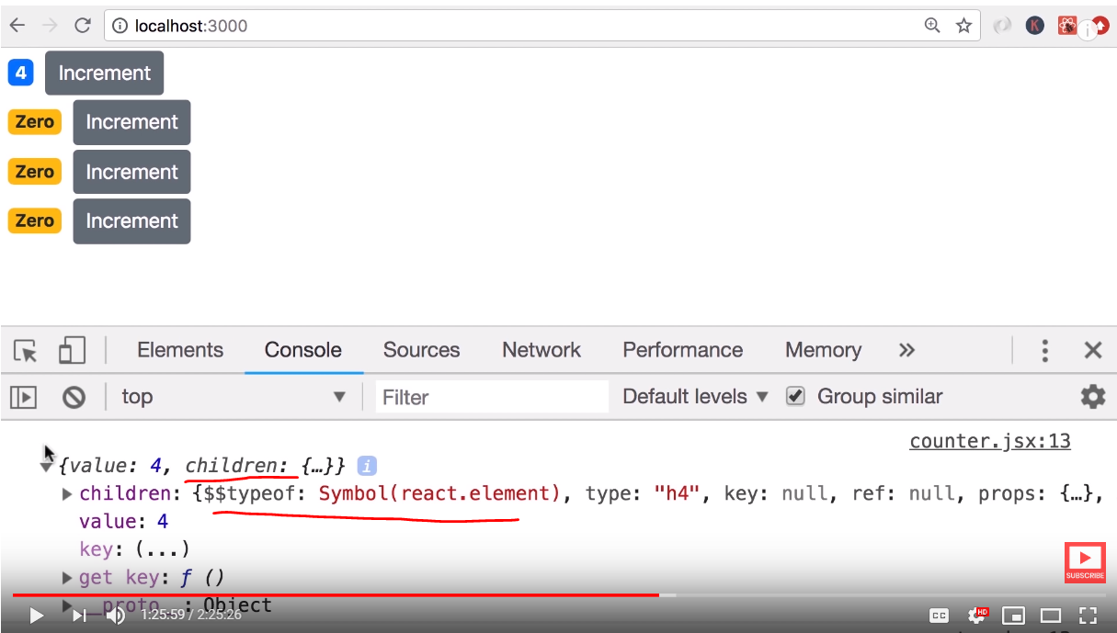

If you see the child is nothing but the H4 we passed

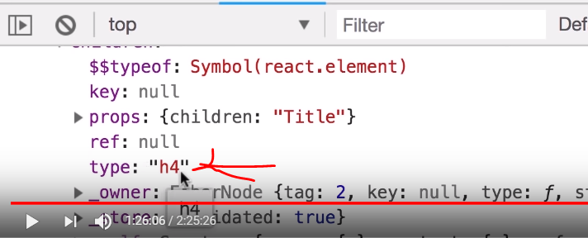

We can simply use it in child as below

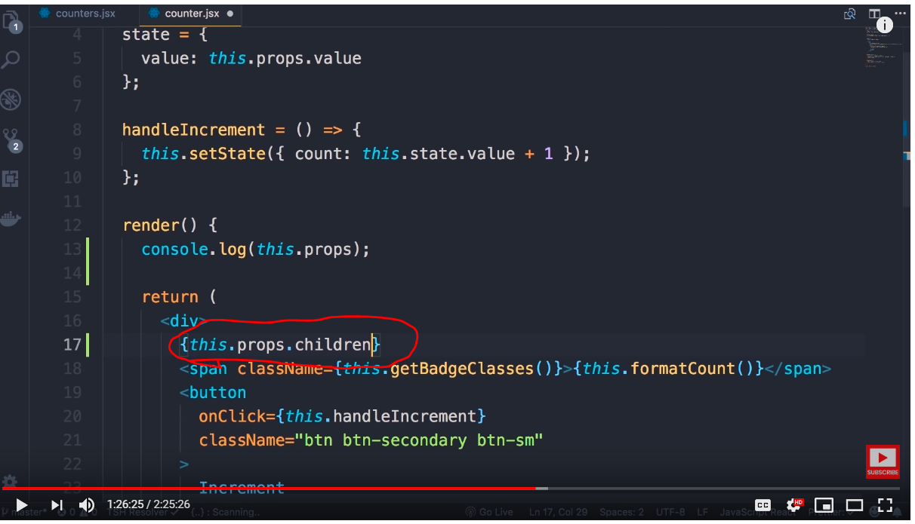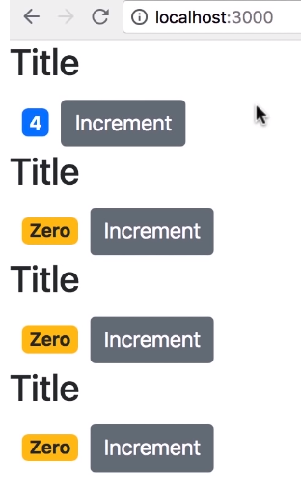

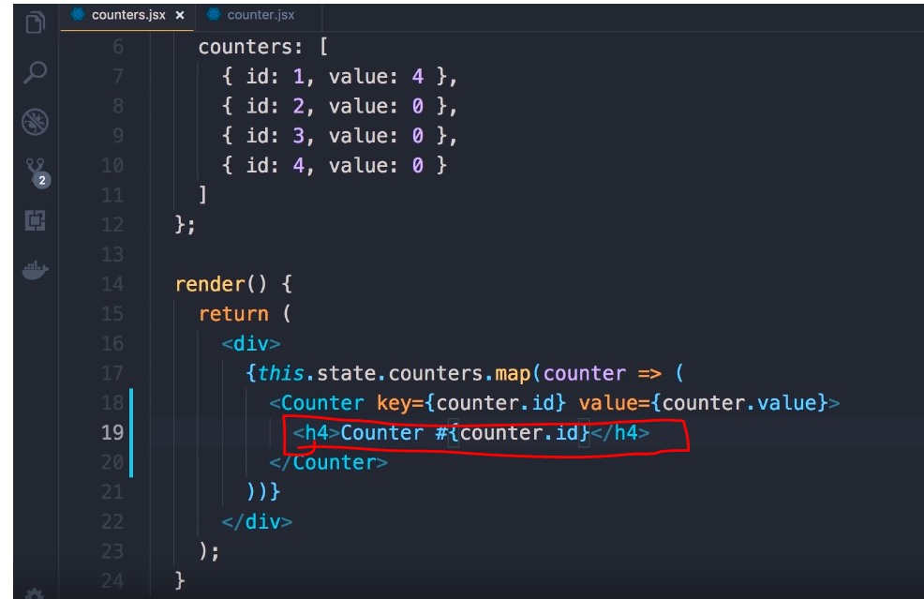 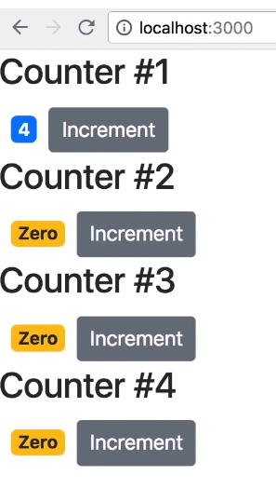

The below code also gives same result

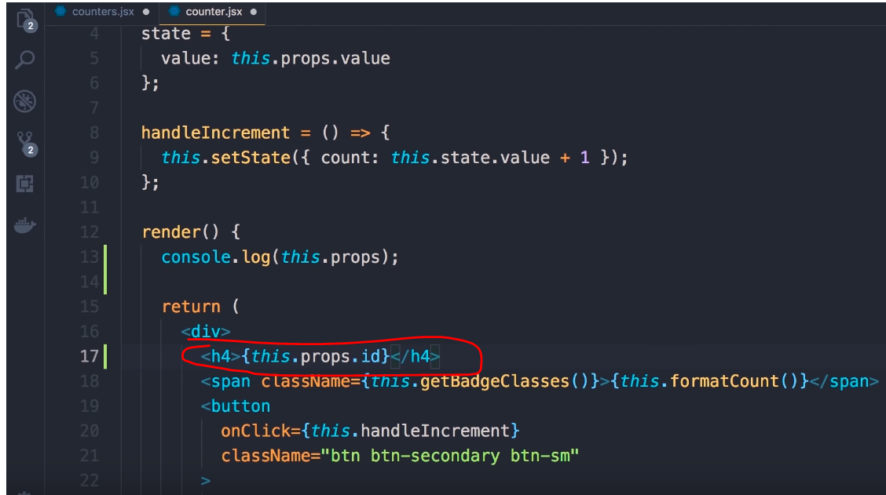



Install react developer tools extensions for chrome

We can see props and state of each component

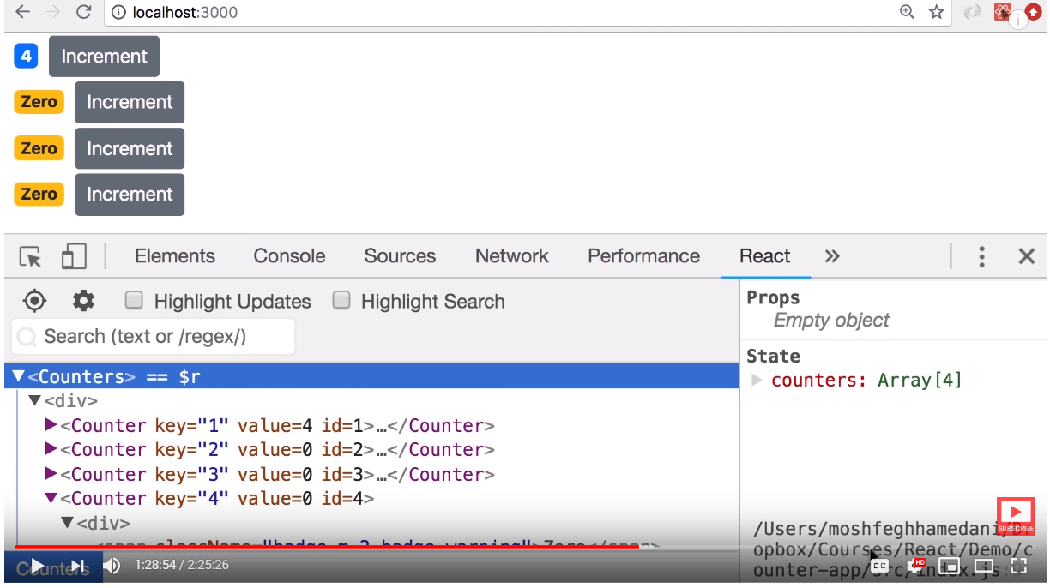

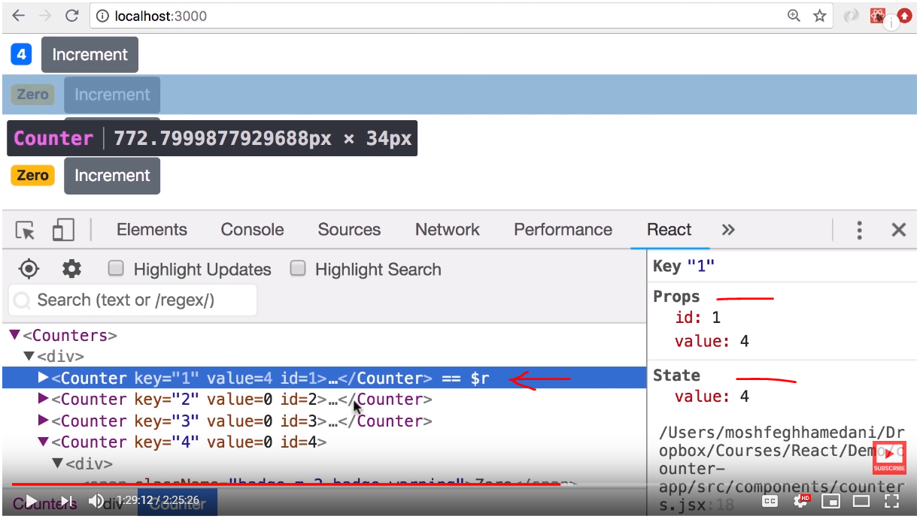

For complex pages we can simply search the component

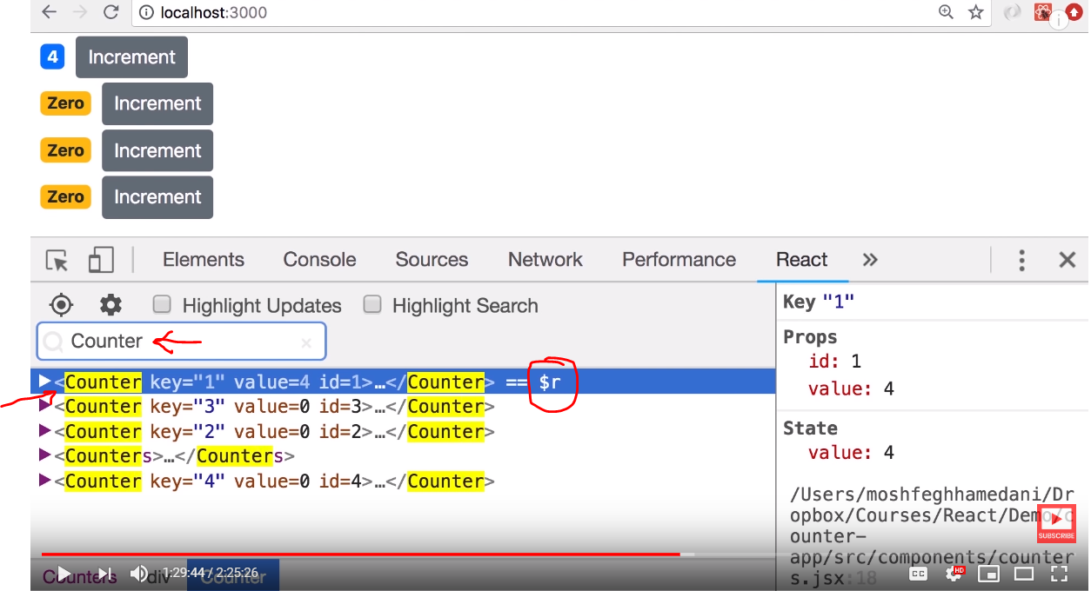

Another useful feature is , notice $r as we select each component

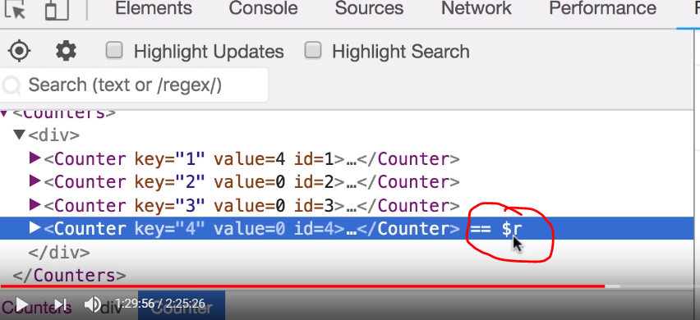

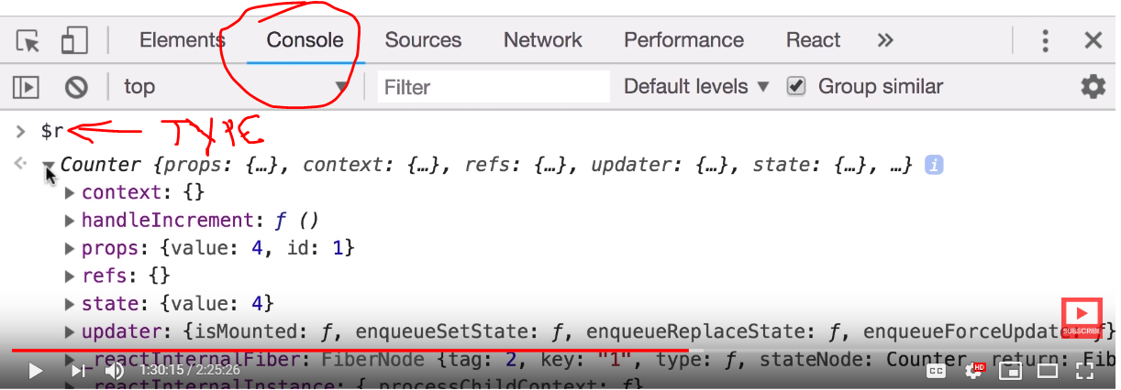

If we type $r in console we get the instance of the component

$r.render() will get react element itself

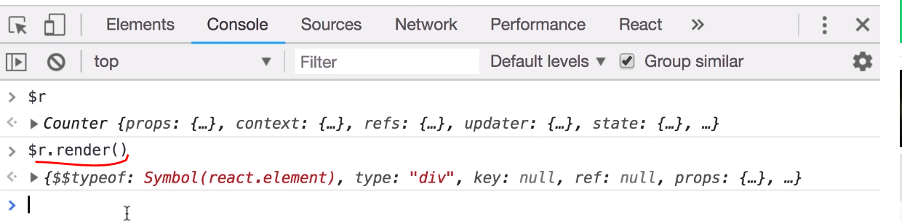

Another feature

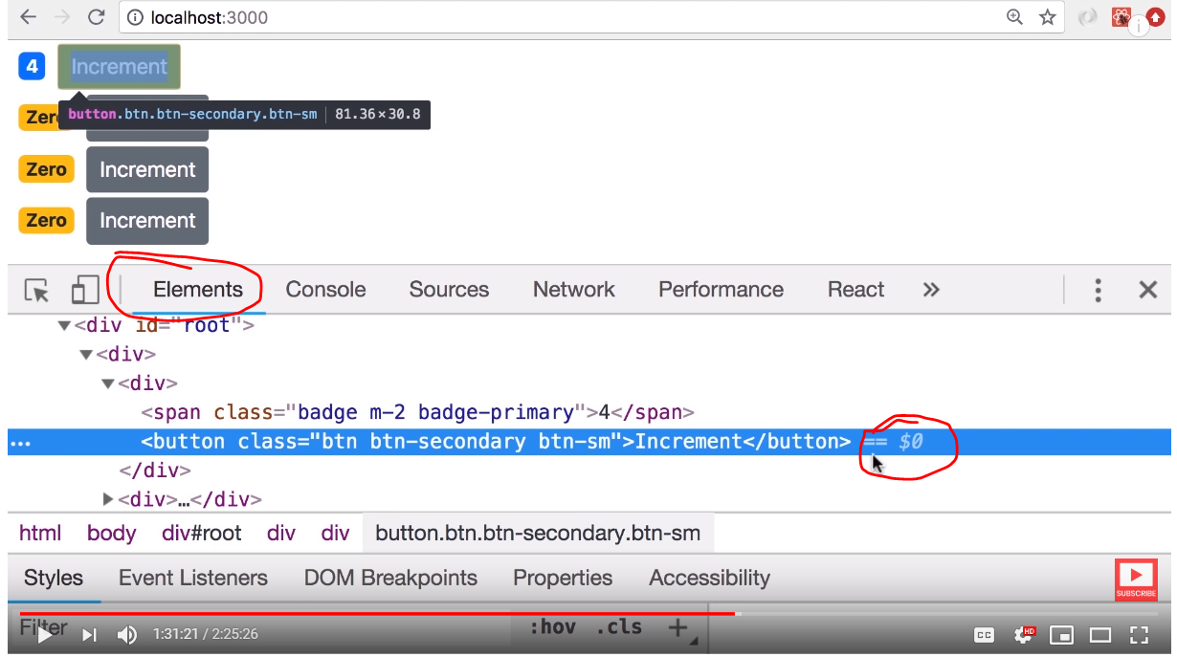

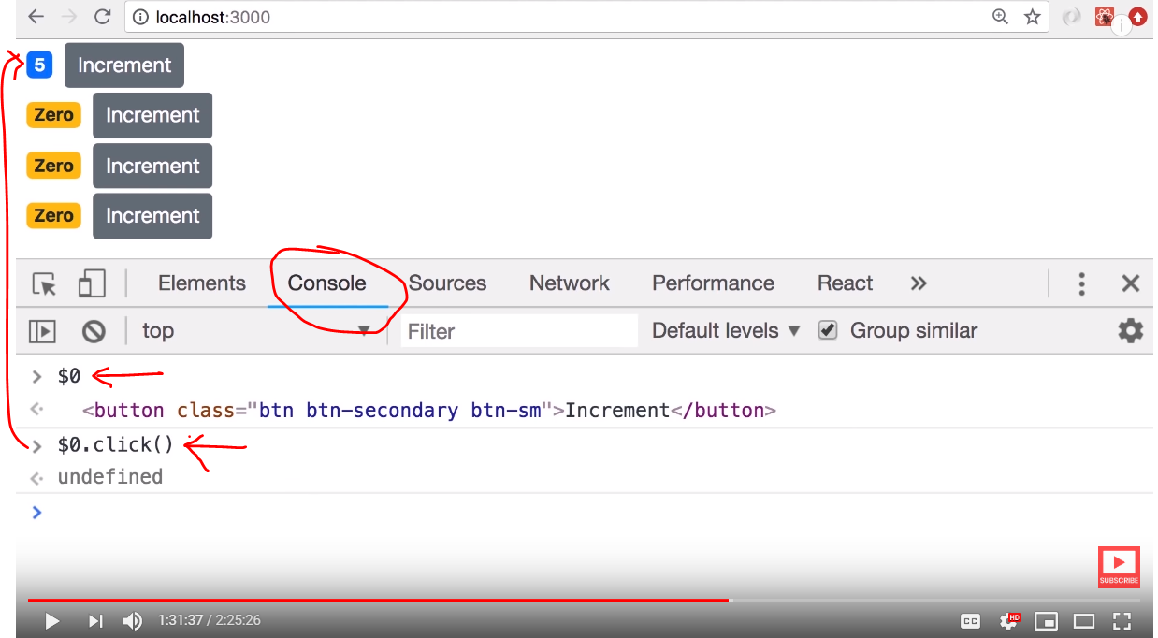 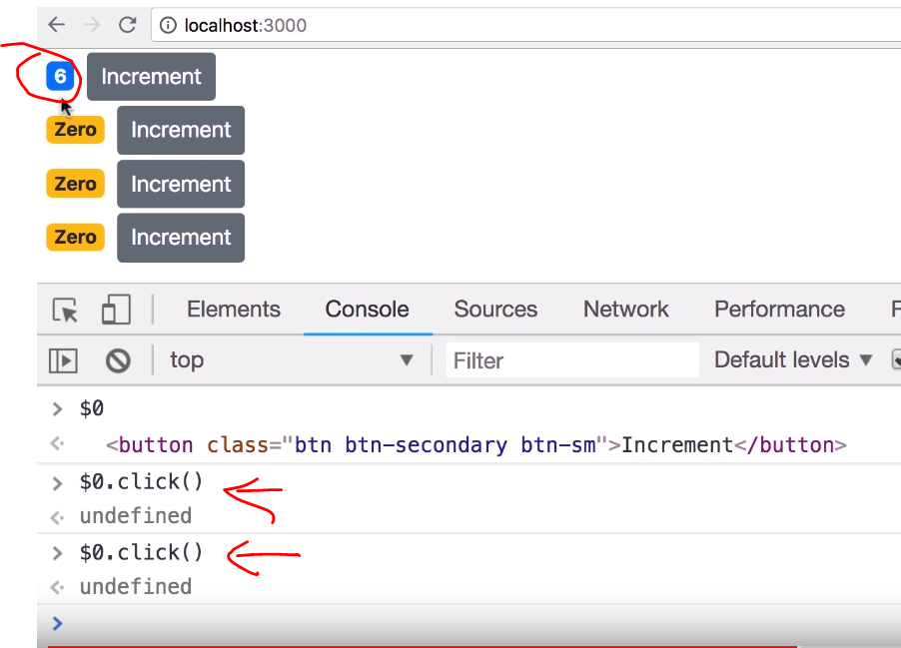

We can imitate the click event of individual component in developer tools

This way react makes building components and debugging very easy



Props – The data we give it to the component

State – The local data or private data of the component

The state can not be accessed from outside , state is internal to the component

Props is read only, we can not change the prop value inside the component

Example : try to change the value of a prop as shown below and click the increment button, then see the error

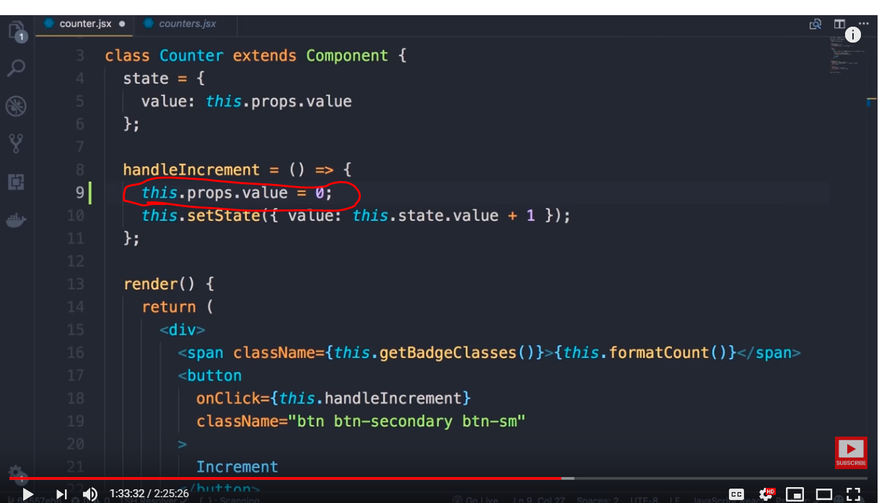 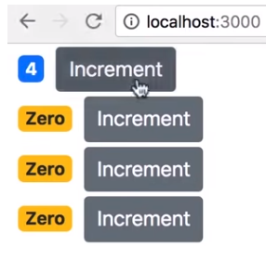

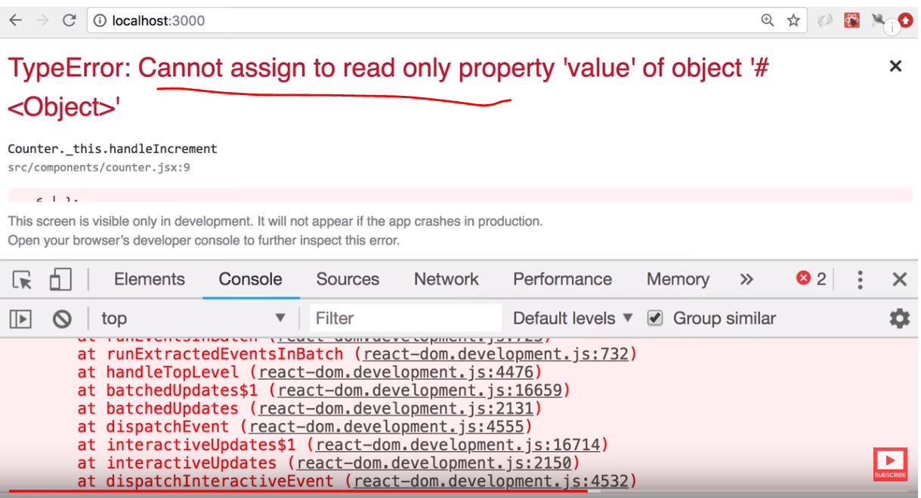

We can assign the prop value to state and modify

Next lets look at raising and handling events

Lets add a delete button to the component

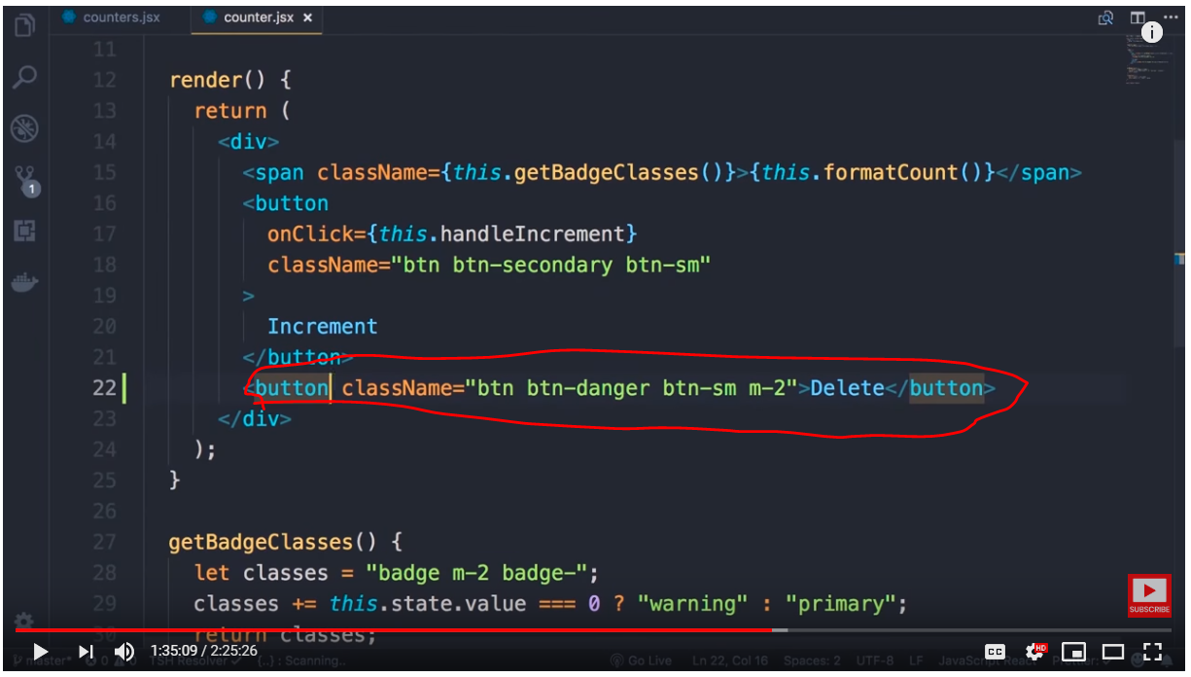 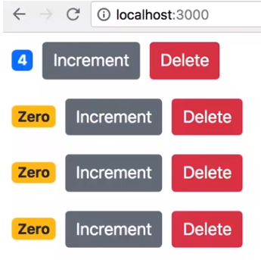

If you observer the child component ( counter component) has only value, if we need to delete the entire counter which is owned by parent conuters component , we need to inform parent component which owns the state of entire list of counters (from which the selected counter needs to be deleted)

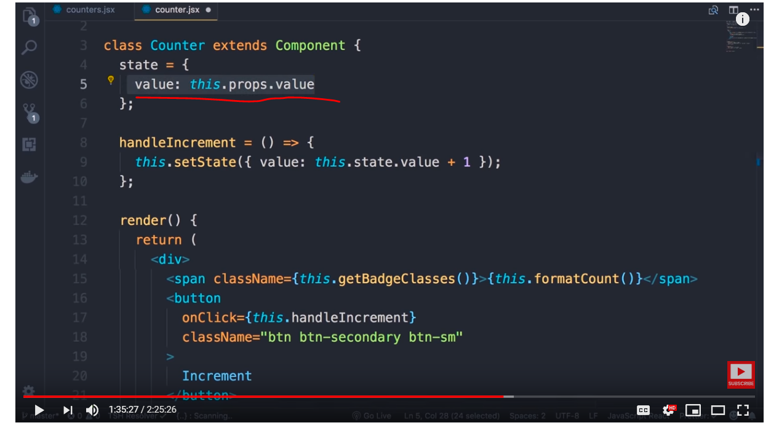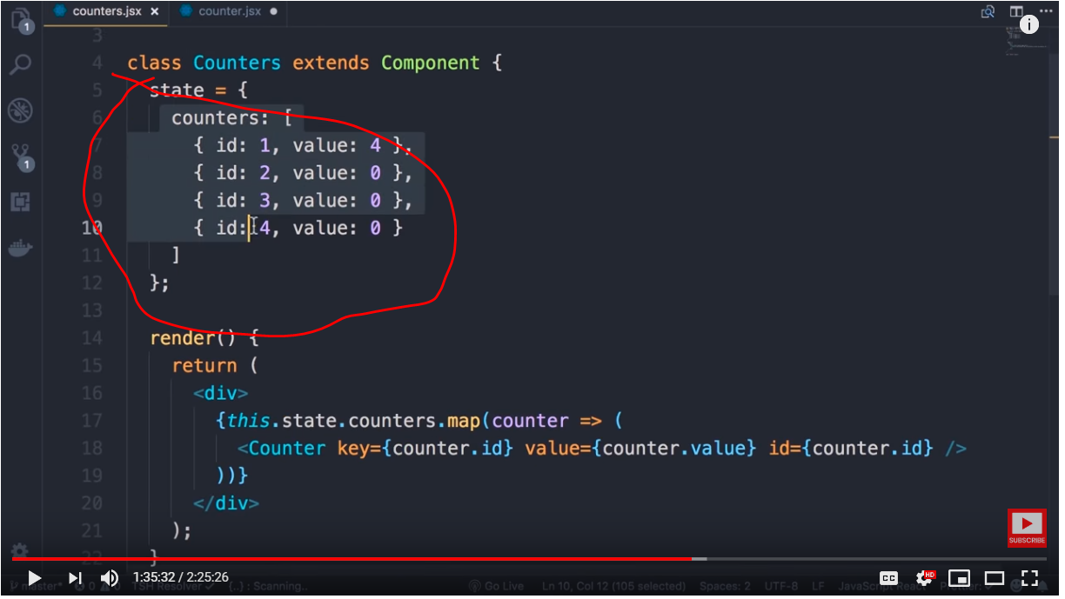

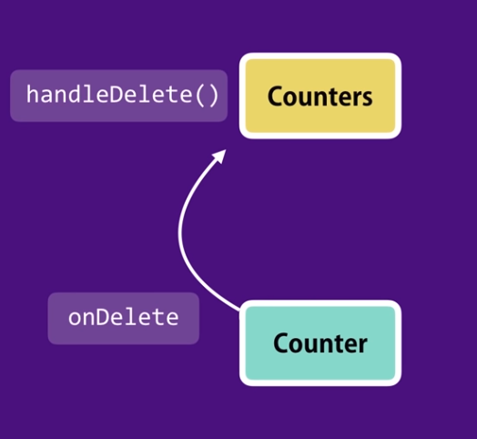

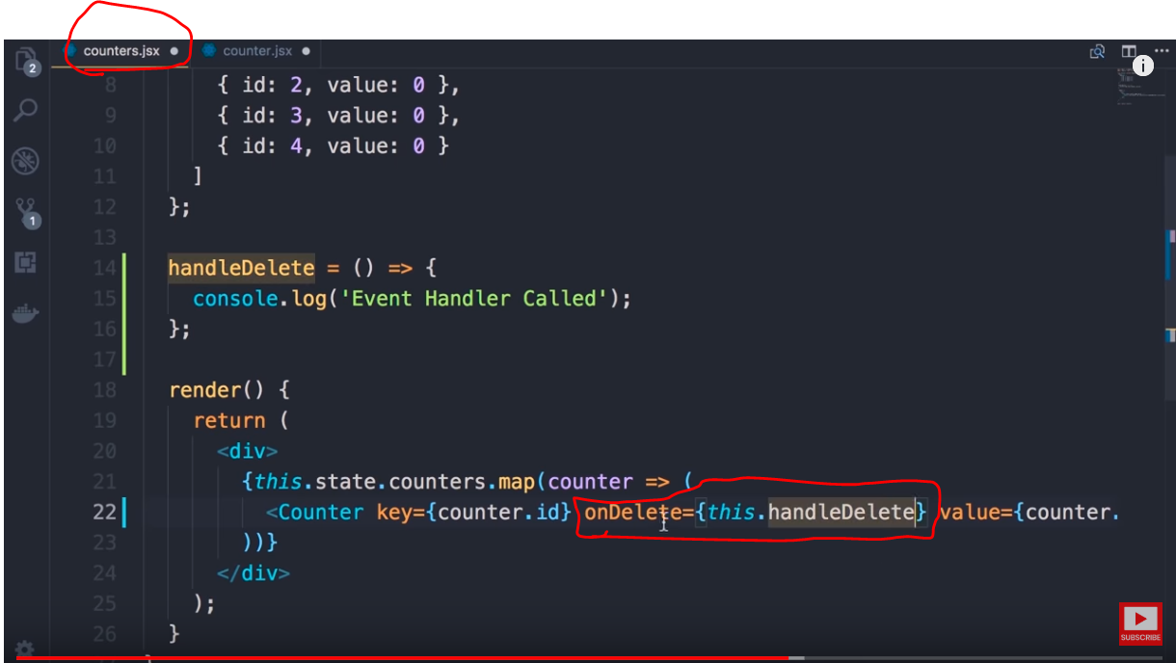 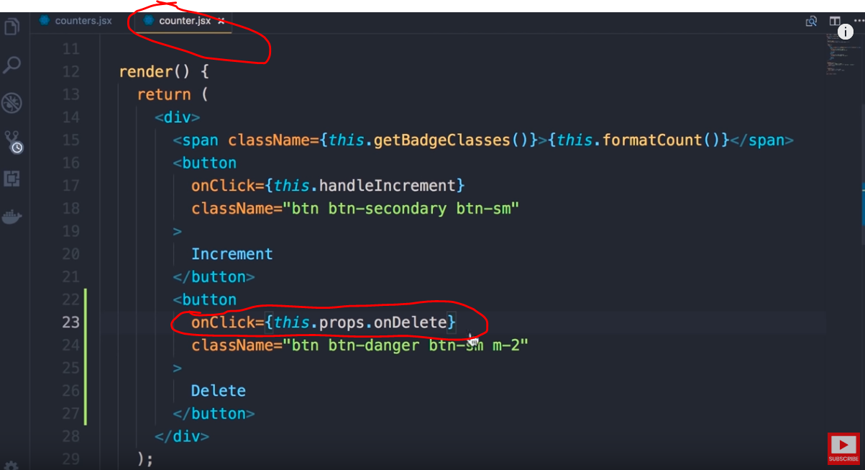

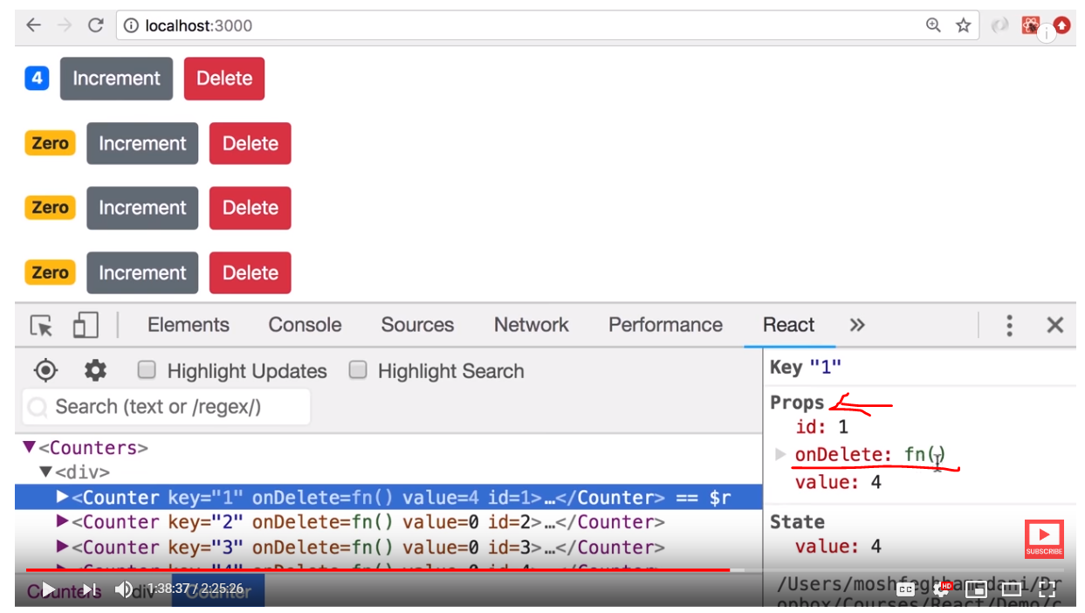

In the next section we will do the actual delete



As we need say exactly which child is raising the delete event we need add below arrow function with the id

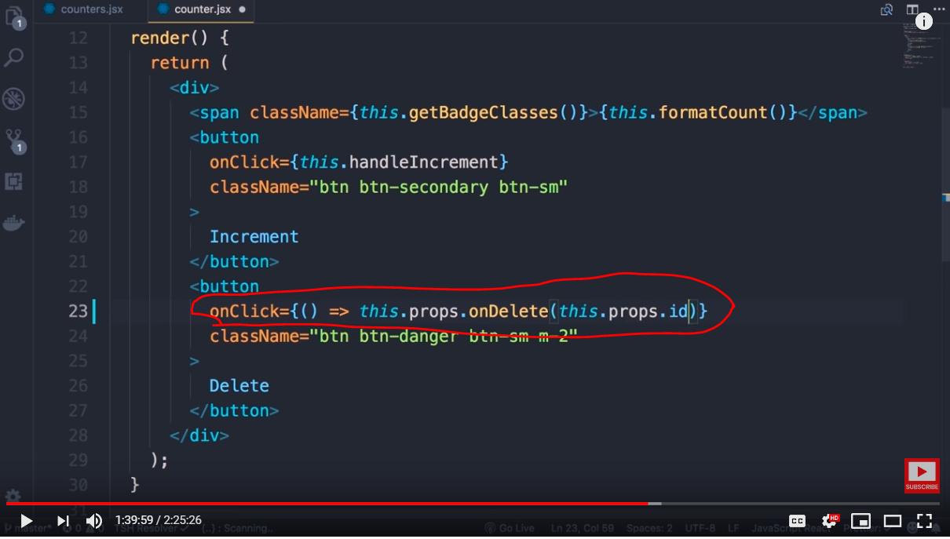 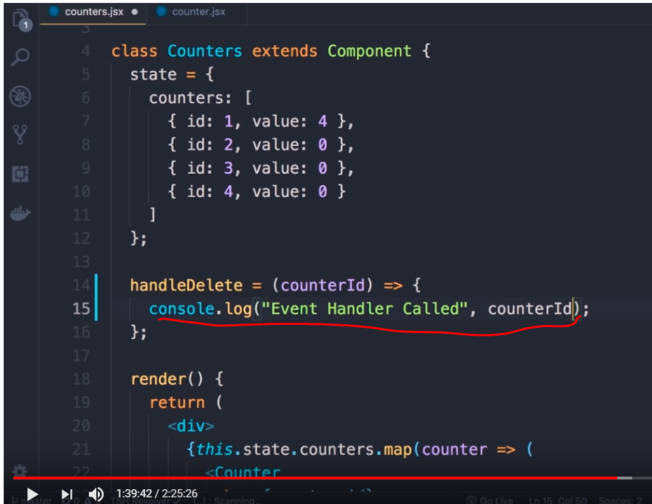

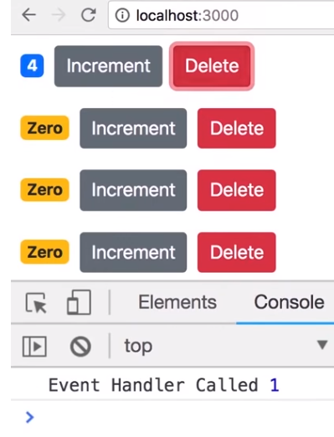

Doing the actual delete using below code change , as we can not modify the state directly we need to use setState method with new state to change

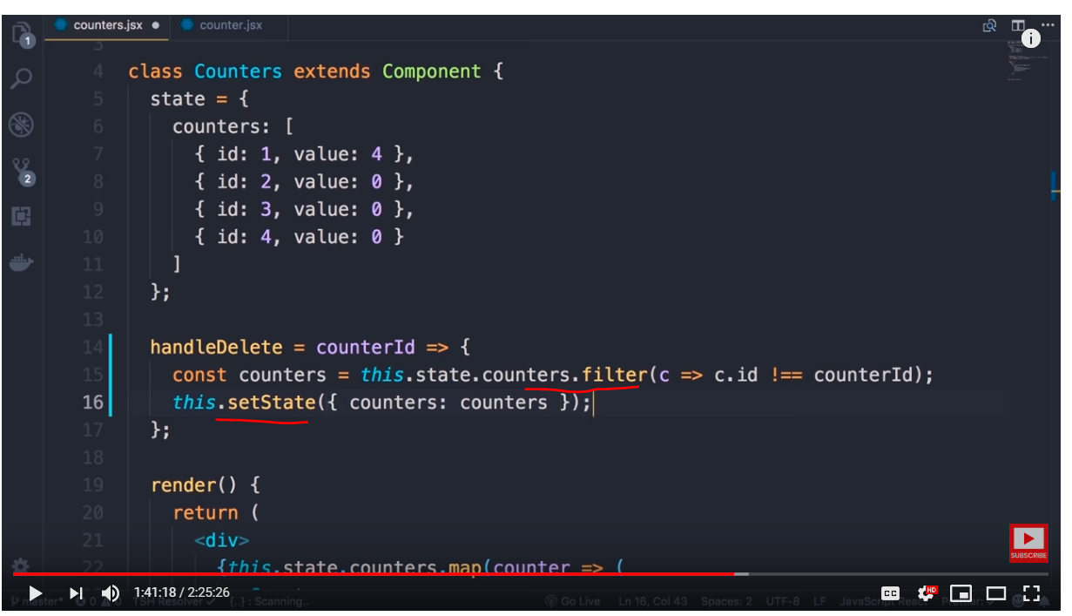

Next topic

If we observer we are using both key and id , key is used for internal purpose and not passed to prop and id is

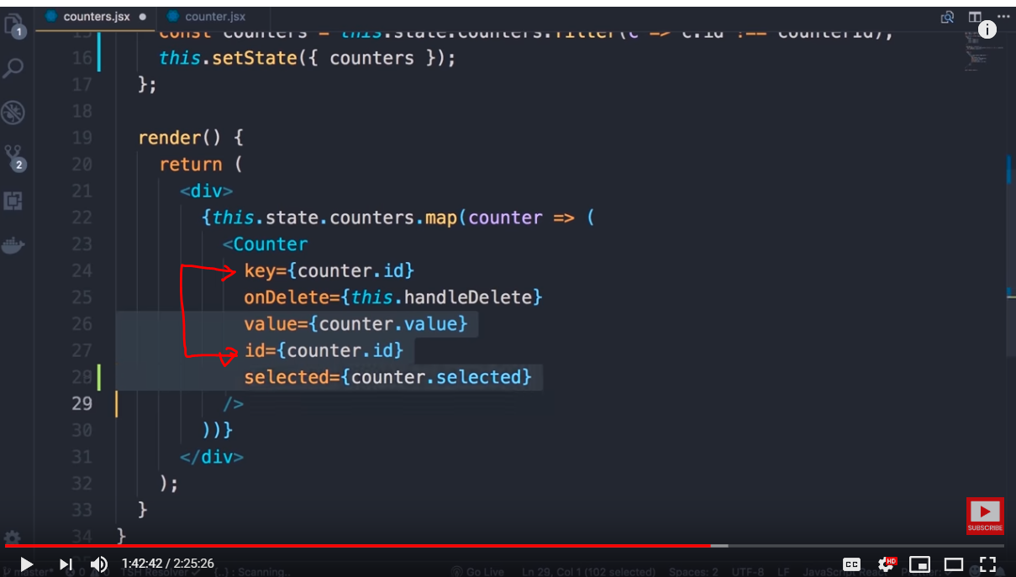

As we can see based on the need the number attributes and respective values assigned to a component could increase. It would look ugly, the whole point of object is to use encapsulation

We can replace all the properties( attributes) into a single object as below and in future if we add more properties we don’t need to modify the HTML, our counter object is carrying all the data about the counter

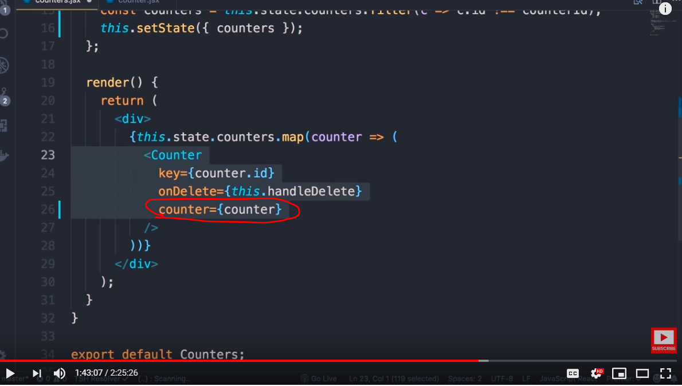

Make below changes in the child component which receives the entire counter object as input to props instead of individual fields

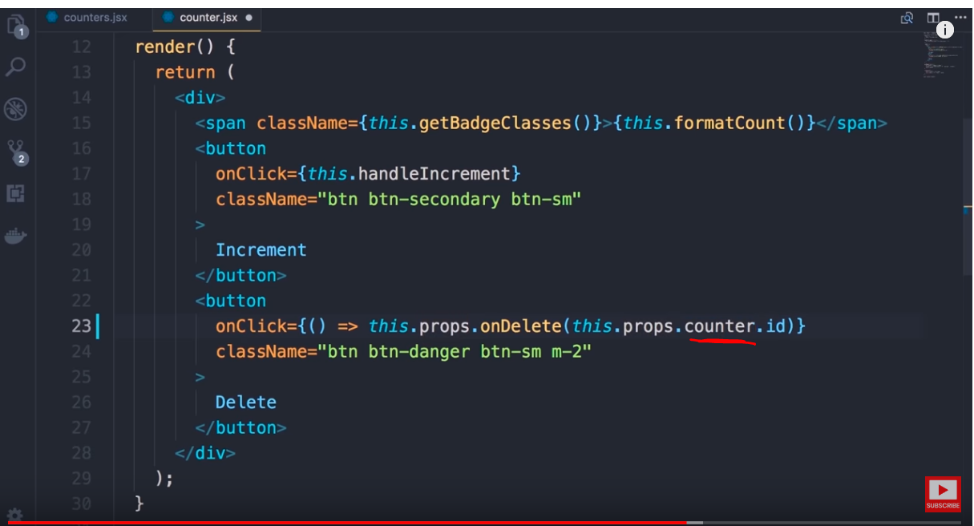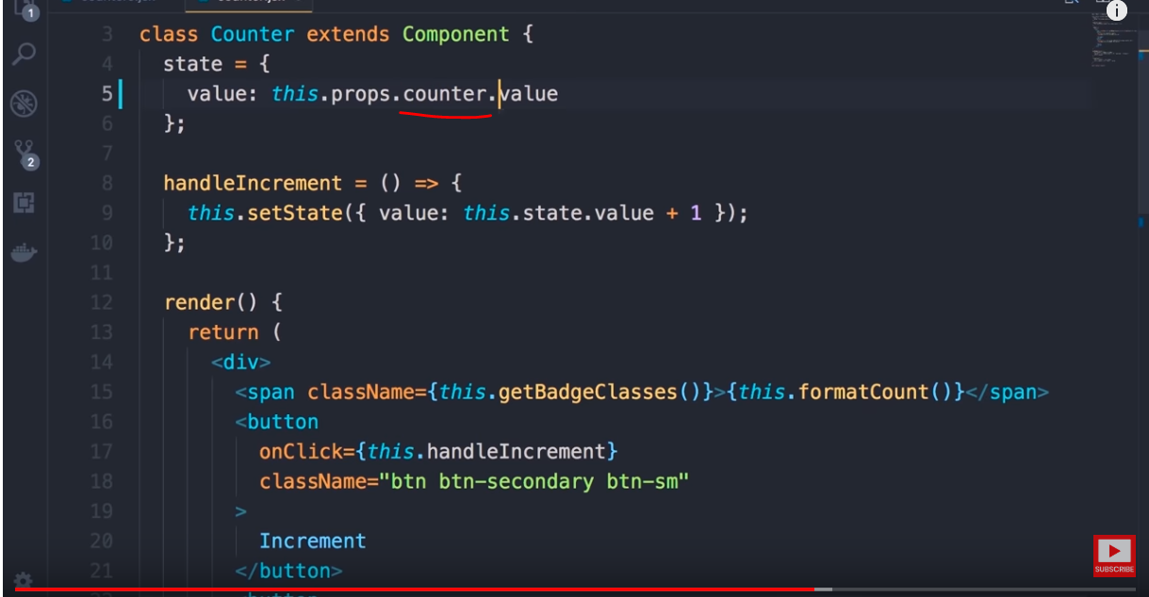



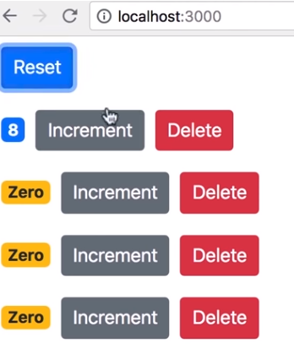

1. When we click on increment, we can access local state and increase the counter value
2. But when we click on reset button we can not reset the counters of all counters as we do not have access to the state of the child components
3. In order to achieve this we need to remove local state and have a single source of truth

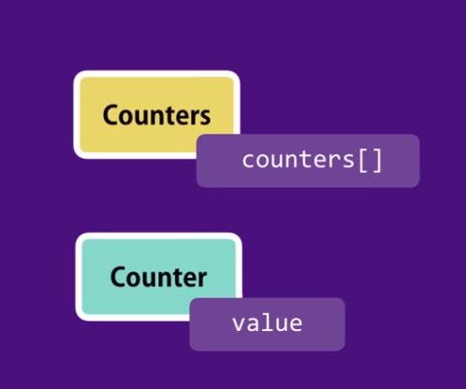 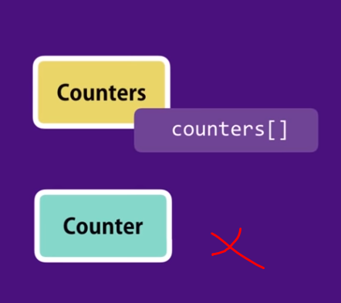



Remove local state and pass the data from parent , such components are called controlled component which are completely controlled by parent and can only raise events

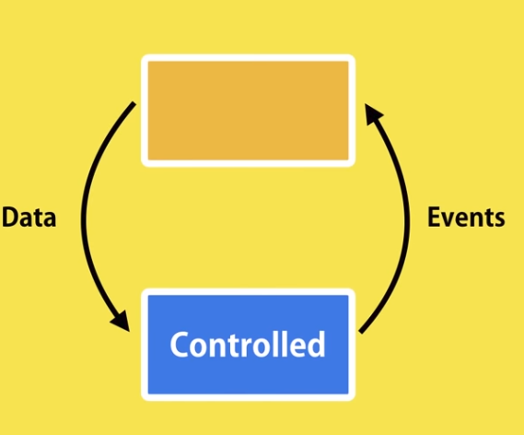

Remove local state and all references to local state

The existing onClick changes as below

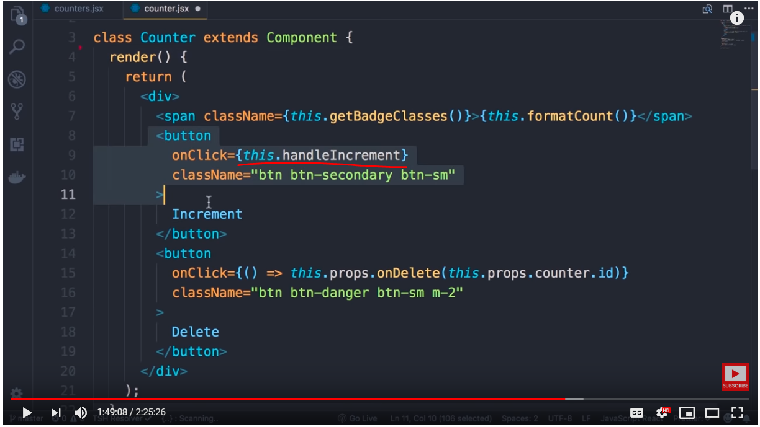 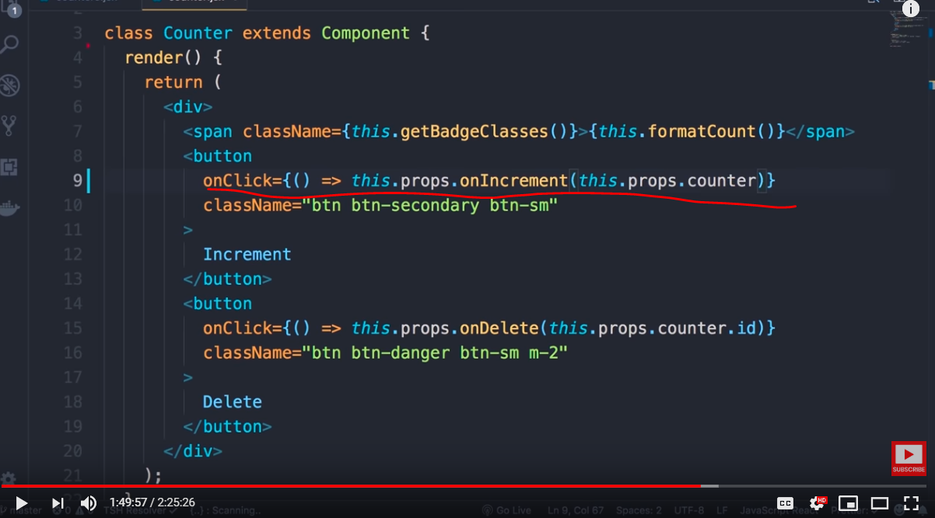

Now implement the handler in parent component, though it clones the state but modification is directly reflected to the state, which is a no no in react , we need to use setState to modify

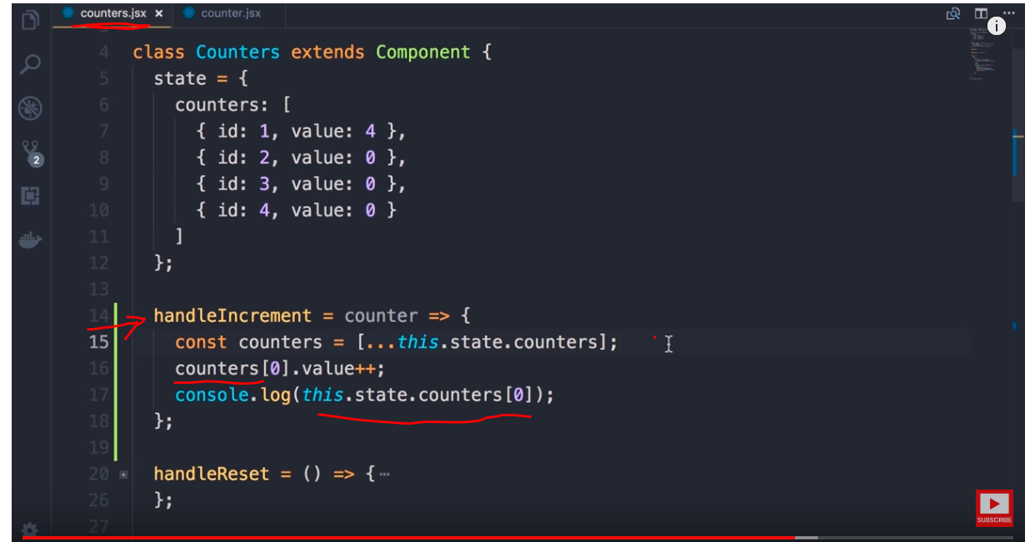 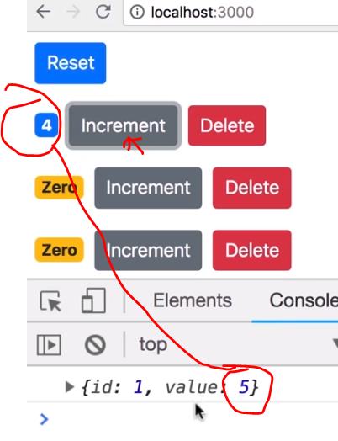

Clone only that counter which is under modificaiton , for example if you want only first counter then below code will work

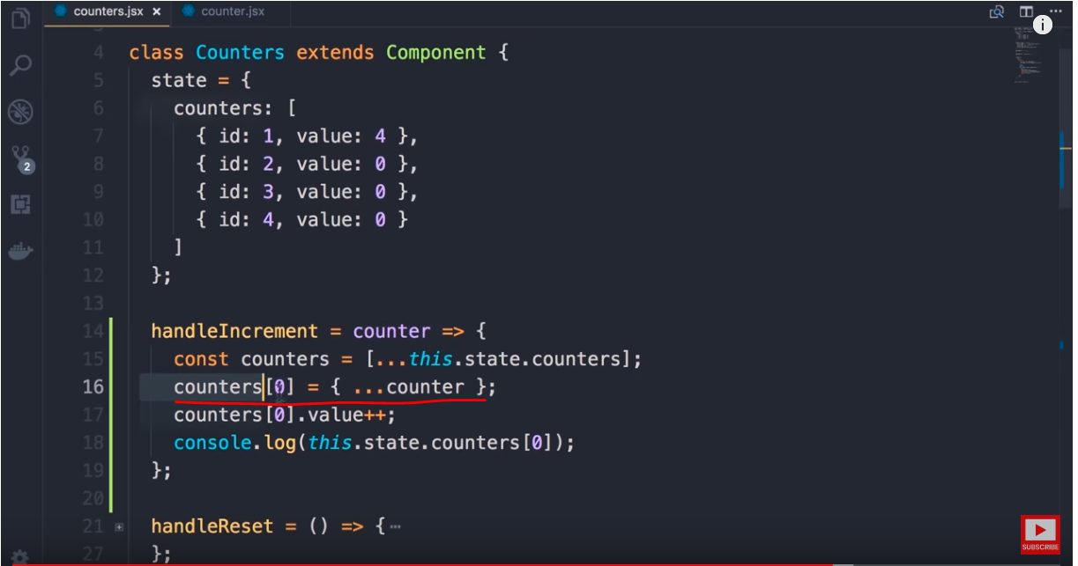 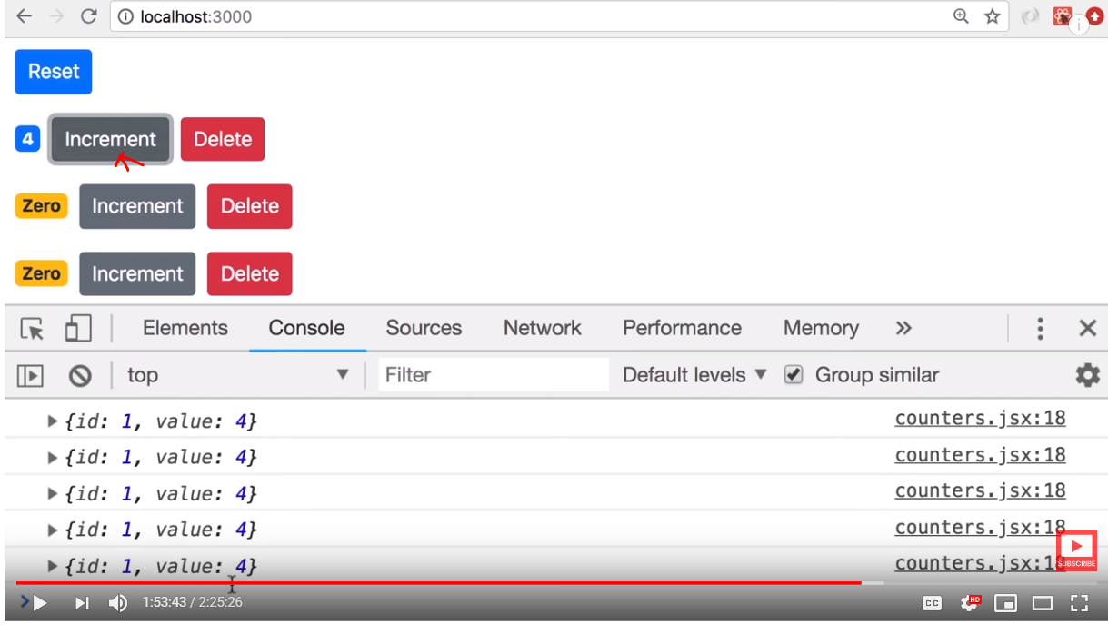

Final code which works for any counter is below

